Sunday, December 4, 2011 – Second Sunday of Advent – Communion Sunday
The Throne that Rules the Universe!
Revelation 4:1-5:14
³ And the One who sat there had the appearance of jasper and carnelian. A rainbow, resembling an emerald, encircled the throne. Revelation 4:3 (NIV84)
-----------
Today in the book of the Revelation, we get a new start. That is, we begin a new section in the book. And according to the hypothesis on which I am approaching Revelation, the story we find in chapters 4-7 should span the period from Christ’s first coming to His second.
Let me summarize section two in a few sentences. Revelation 4-7 is a tale of two sons. Son #1 has a harsh and unloving father. Son #1 feels no sense of security in life. Has no confidence to face life’s challenges.
Son #2 has a loving yet firm father. Son #2 feels confident about facing the challenges of life.
Both boys experienced the same set of conflicts, persecutions and natural catastrophes, the same trials and circumstances. Son #1 grew bitter, angry and rebellious and was totally unequipped to face the everyday pressures of life. Son #2 deepened in his love for his father and internally was a conqueror when facing everyday pressures, including the catastrophes – all because he knew his father had placed his confidence in His heavenly Father who was in control of all things.
If this story just made sense to you, then you now understand Section 2 of Revelation, chapters 4-7. When we are confident that our heavenly Father is in control, we can trust Him through all challenges, even death.
For most of us who now have a few years of life under our belts, we have come to realize that real life is filled with a potpourri of highs and lows, joys and sorrows, good and bad, peace and conflict, dreams and failures. And for many us, our discovery is that we seem to get a disproportional number of the negatives.
In addition to this, we have all seen how different people weather the storms of life. Some have come through stronger. Others have been destroyed by the storms. And it also appears that for the genuine Christian, there are additional pressures that God allows to be brought our way to keep us calling out, even, crying out to Him to help us, to guide us, to keep us strong and protect us.
This morning, I want us to work with the question: What makes us confident conquerors of all that life throws at us?
In the section of chapters 1, 2 & 3 of Revelation, we have already noted that there are forces working against us to dissuade us to place our hope and confidence in Almighty God. I called these the crises of Lordship. I summarized the first section of this book this way: “The ascended, glorified, warrior Christ is living in and with His Church as Lord to cleanse her and protect her and bring her into the blessings and glories of heaven by empowering her to overcome all hindrances to Christ’s right to rule and reign among His people.”
God, through the book of the Revelation, wants to make it clear to us that God’s people have an enemy who is trying to undermine our trust in Him. But He wants to make it even clearer that we have a conquering Savior and King who leads us to victory if we will just keep trusting Him.
We can conclude from this that one of the primary purposes of the Revelation of Jesus Christ is to build our confidence in Christ’s supreme authority and power. Over and over again, we are hearing and seeing in this book that Christ conquers, that the Lamb wins. We see Him as our Shepherd who leads us to springs of living water (7:17). We see that the kingdom of the world has become the kingdom of our Lord and of His Christ, and He will reign for ever and ever (11:15). We see that He who was seated on the cloud swung His sickle over the earth and the earth was harvested (14:16). We see that God remembered Babylon the Great and gave her the cup filled with the wine of the fury of His wrath (16:19). We see that the armies of heaven were following Him, riding on white horses and dressed in fine linen, white and clean. . . . On His robe and on His thigh He has this name written: King of kings and Lord of lords (19:15-16). And finally, we see the end result of Christ’s warring against evil. A loud voice from the throne says, “Now the dwelling of God is with men, and He will live with them. They will be His people, and God Himself will be with them and be their God. ⁴ He will wipe every tear from their eyes. There will be no more death or mourning or crying or pain, for the old order of things has passed away” (21:3-4).
Over and over our confidence in Christ as our Warrior King is built as the story of the Revelation of Jesus Christ unfolds. It is no less true as we enter this second section of the book at chapter 4. It is here that we are privileged to ride the coat tails of the Apostle John and view with him the throne in heaven.
This picture of heaven we see in Revelation 4 should not be unfamiliar to us. We have seen this picture before as we have followed the story of God leading His children Israel out of Egypt into the Promised Land.
God wanted the children of Israel to see a picture of His throne room in heaven. So, what did He do? How did He give them this picture?
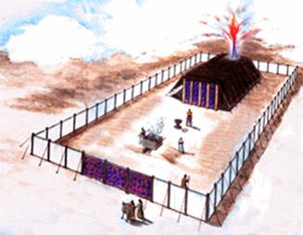
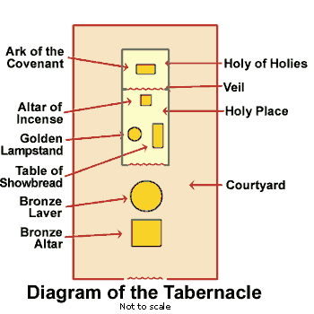
He had them build a tent, called the Tabernacle, with two rooms, one piece of furniture in the smaller of the two rooms and three pieces of furniture in the larger. The small room, in the shape of a cube was called the Holy of Holies. Its sole article of furniture was the Ark of the Testimony.
In the larger room, called the Holy Place, were the Table of Showbread with its twelve loaves of bread, the Lampstand with its seven lamps, and the Altar of Incense, a place of offering up prayers. There were two fixtures built for outside the Tabernacle, the altar of burnt offerings and the basin for washing.
Exodus 25:1-2, 8-9 (NIV84) ¹ The Lord said to Moses, ² “Tell the Israelites to bring Me an offering. You are to receive the offering for Me from each man whose heart prompts him to give.
⁸ “Then have them make a sanctuary for Me, and I will dwell among them. ⁹ Make this tabernacle and all its furnishings exactly like the pattern I will show you.
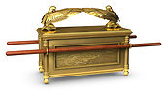
Exodus 25:10-22 (NIV84) ¹⁰ “Have them make a chest of acacia wood—two and a half cubits long, a cubit and a half wide, and a cubit and a half high. ¹¹ Overlay it with pure gold, both inside and out, and make a gold molding around it. ¹² Cast four gold rings for it and fasten them to its four feet, with two rings on one side and two rings on the other.

¹³ Then make poles of acacia wood and overlay them with gold. ¹⁴ Insert the poles into the rings on the sides of the chest to carry it. ¹⁵ The poles are to remain in the rings of this ark; they are not to be removed. ¹⁶ Then put in the ark the Testimony, which I will give you.

¹⁷ “Make an atonement cover of pure gold—two and a half cubits long and a cubit and a half wide. ¹⁸ And make two cherubim out of hammered gold at the ends of the cover. ¹⁹ Make one cherub on one end and the second cherub on the other; make the cherubim of one piece with the cover, at the two ends. ²⁰ The cherubim are to have their wings spread upward, overshadowing the cover with them. The cherubim are to face each other, looking toward the cover.

²¹ Place the cover on top of the ark and put in the ark the Testimony, which I will give you. ²² There, above the cover between the two cherubim that are over the ark of the Testimony, I will meet with you and give you all My commands for the Israelites.

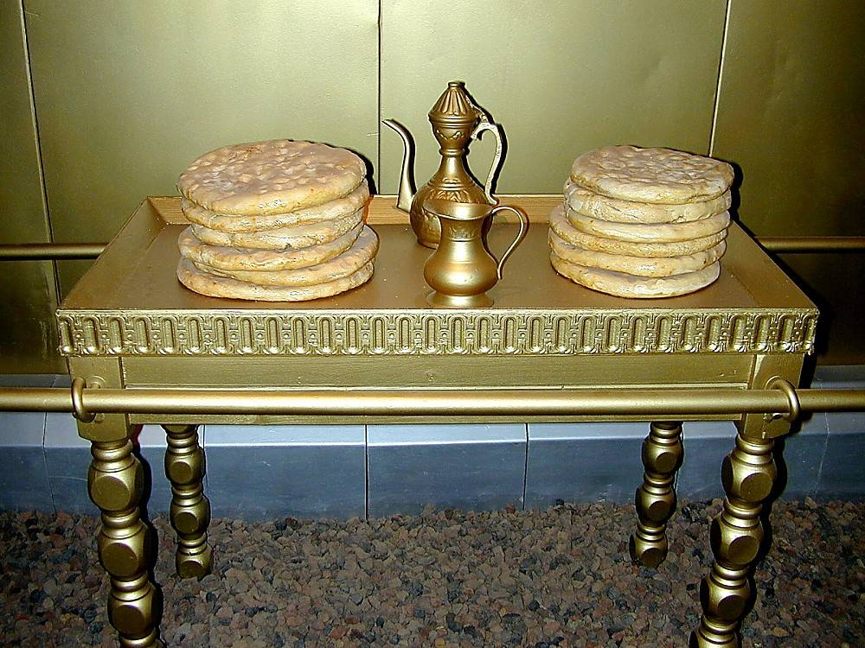
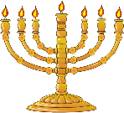
What follows the construction of the Ark are the Table of the bread of God’s Presence and the Lampstand with its Seven Lamps to light the space in front of them. Then the Tabernacle is to be built with two rooms, one the Holy Place and the other the Holy of Holies in which the Ark is to be placed.
God wanted the children of Israel to have an idea of what His throne room in heaven looked like. So He gave them the Tabernacle. Thus, when we are given a vision of the throne in heaven, we should already be prepared for what we will see. Folks, I’m not making this up.
Keep in mind as I read this next verse that temple and tabernacle are basically interchangeable words. Revelation 11:19 (NIV84) ¹⁹ Then God’s temple in heaven was opened, and within His temple was seen the ark of His covenant. And there came flashes of lightning, rumblings, peals of thunder, an earthquake and a great hailstorm.
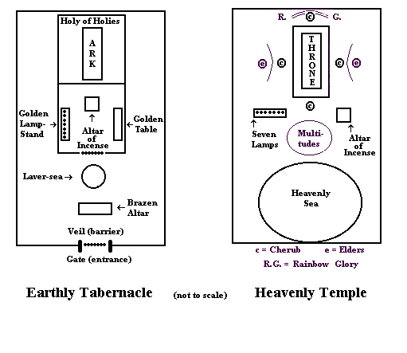
In heaven is a Temple or Tabernacle and within that temple is the Ark of the Covenant. This information should help us see more clearly John’s description of the throne in heaven in Revelation 4.
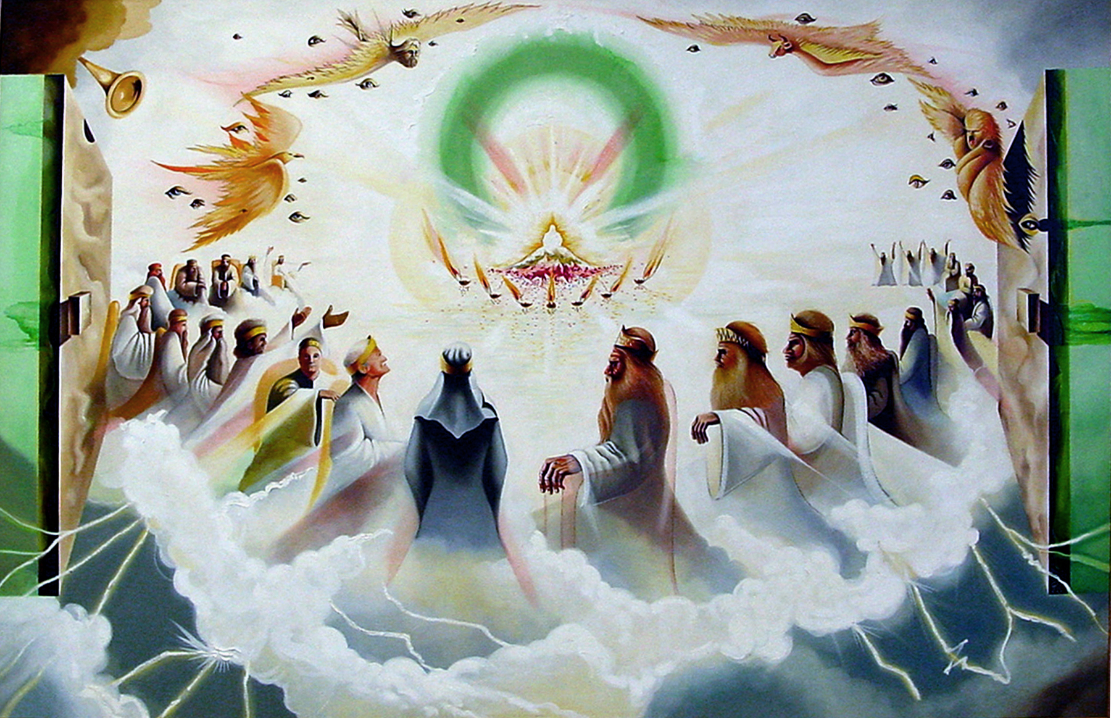
Let’s not forget that the English word Revelation comes from the Greek word apocalypse. It means to unveil in wholesale fashion, to reveal dramatically or to dazzle by open displays of God’s power and glory. What a rousing vision the writers delivered to hurting hearers then, and to an anxious generation now! Lifting up key universal themes about God’s Kingdom, they took believers to the Throne of Heaven. By painting word pictures with “apocalyptic” colors the prophets shared striking snapshots that, on our side of the Ascension, take us straight to Christ as our hope.
Now, I hope I have adequately prepared you to hear and see the Throne in heaven as I read to you Revelation 4:1-11 (NIV84)
¹ After this I looked, and there before me was a door standing open in heaven. And the voice I had first heard speaking to me like a trumpet said, “Come up here, and I will show you what must take place after this.” ² At once I was in the Spirit, and there before me was a throne in heaven with someone sitting on it. ³ And the One who sat there had the appearance of jasper and carnelian. A rainbow, resembling an emerald, encircled the throne.
The “door” conveys a sense that there was a limit to what John was able to see. Not everything was visible to him. Plus, what he did see was too awesome to adequately describe. He does see that “someone” is seated on the throne. Seven times in chapters 4 & 5 John says that someone was seated on the throne (4:2, 3, 9, 10; 5:1, 7, 13). And he leaves no doubt in the reader’s mind that the “someone” is Almighty God. By the frequency of mention, the word throne dominates this chapter. Thirteen times in these eleven verses.
This is more than a hint, folks. John is making a point. Triune God is the supreme ruler of this universe. “He governs everything so that nothing happens without His will, whether good or evil. He assures us that He and not Satan is in control.”
Now, if you know what’s coming in terms of trials for the church in chapter 6, you just might be asking yourself, why so much emphasis on the throne in heaven just in advance of what must soon take place? Think with me, please. Would it help you to face the trials that are coming your way if you knew in advance that God was in control and not Satan? Knowing this, surely, we can trust Him in the midst of our trials.
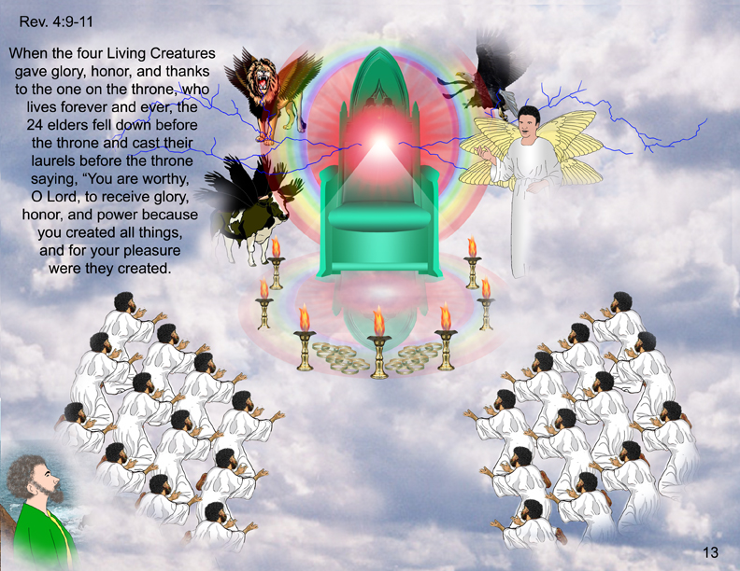
When once again John speaks of the throne in heaven with someone sitting on it, he attempts to describe that person’s appearance. He brings up colorful stones and a rainbow. But in the case of the jasper, it is more like a diamond than a opaque stone. We get that from John’s description of a jasper in Revelation 21:11 (NIV84) ¹¹ It shone with the glory of God, and its brilliance was like that of a very precious jewel, like a jasper, clear as crystal.
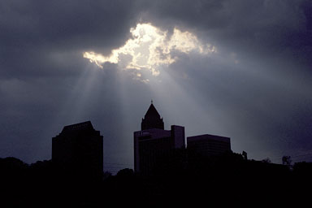
What John is doing in his description of God is pointing to brilliant beauty and awe-inspiring colors. It reminds me of those startling scenes in the sky that stand out with brilliance and beauty. Like Friday afternoon, a rather overcast and dreary day, until an opening in the clouds occurred in the west. At the same time, the sun showed its intention to head towards the horizon. And suddenly, there was the most brilliant white light beaming through that opening and I could not think of anything but of the One who is sitting on the throne in heaven. All that was missing was for lightning to flash and thunder to roll. It is the picture of the majesty of our God, the closest we may ever get to seeing the Father with our eyes.
⁴ Surrounding the throne were twenty-four other thrones, and seated on them were twenty-four elders. They were dressed in white and had crowns of gold on their heads. ⁵ From the throne came flashes of lightning, rumblings and peals of thunder. Before the throne, seven lamps were blazing. These are the seven spirits of God. ⁶ Also before the throne there was what looked like a sea of glass, clear as crystal.
Surely, these words take us into the tabernacle of God. The clearest connection for us to the Holy Place would be the seven lamps that were blazing. Chapters 1, 2 & 3 got us well acquainted with the seven lampstands. Here, the focus is on the lamps that sit on the lampstand and John tells us that those lamps are the seven spirits of God. Clearly, this is the Holy Spirit being symbolized here. But there are yet two other pieces of furniture in the Holy Place. Could it be that the twenty-four elders are symbolized by the table of showbread? I ask that because of the strong connection bread has with fellowship, even fellowship or communion with God.
We know that there were twelve loves of bread on the table in the Holy Place. Would they not be representing the twelve tribes of Israel? I rather suspect they would. Furthermore, what else surrounds the throne in heaven that would connect with the table of showbread better than the twenty-four elders?
Attacking this more from the clues in the text, the twenty-four elders likely represent all the redeemed, all the believers. Take note that they are dressed in white, wear crowns of gold on their heads and sit on thrones. We know that it’s the saints who “are invited by Jesus to sit with Him on the throne (Revelation 3:21) and the saints in heaven are given authority to judge by sitting on thrones (Revelation 20:4). Plus, there is a distinct difference between angels and saints. First, not angels but saints receive this privilege (1 Corinthians 6:2–3). Further, crowns symbolize authority to rule with Christ (Revelation 3:21; 5:10; 20:4, 6; 22:5; 2 Timothy 2:12); this is a privilege granted not to angels but to the saints.”
So what are pictured here are the twenty-four elders surrounding the throne as our representatives. We are there around the throne, at least as represented by the twelve patriarchs and the twelve apostles.
Paul seems to take it a bit further than just being represented there when he says in Ephesians 2:4-6 (NIV84) ⁴ But because of His great love for us, God, who is rich in mercy, ⁵ made us alive with Christ even when we were dead in transgressions—it is by grace you have been saved. ⁶ And God raised us up with Christ and seated us with Him in the heavenly realms in Christ Jesus,
For whatever reason, God wants us to think of ourselves being positioned right now in heaven, joining the hosts in heaven in continual worship, so that whether we eat or drink or whatever we do, we do it all for the glory of God (1 Corinthians 10:31).
In the center, around the throne, were four living creatures, and they were covered with eyes, in front and in back. ⁷ The first living creature was like a lion, the second was like an ox, the third had a face like a man, the fourth was like a flying eagle. ⁸ Each of the four living creatures had six wings and was covered with eyes all around, even under his wings. Day and night they never stop saying:
“Holy, holy, holy is the Lord God Almighty, who was, and is, and is to come.”
Here’s an assignment, maybe we’ll do this during the second half of our service. Read Revelation 4. Then, while you keep looking at what you’ve just read from Revelation 4, have someone read to you Ezekiel chapter 1. Every time you hear something parallel, ring a bell or makes some noise. I assure you, you will be ringing the bell often.
And if you want an even bigger project, read the entire books of Revelation and Ezekiel and see how many times you ring the parallel bell. You will be surprised.
In the text before us, you probably are asking who are the four living creatures. Our text doesn’t come right out and say that they are angels. Nor does it even say they are cherubim (plural for cherub). But, when reading Ezekiel 1 and 10, we for sure can say that the living creatures are cherubim (Ezekiel 10:20). And that fits the Tabernacle model where on top of the Ark of the Testimony or Covenant is the mercy seat with a cherub on either side bowing in worship at the throne of God.
The way these cherubim are described leads one to at least think they share much in common with angels. These cherubim are covered with eyes, suggesting that nothing escapes their attention. As John viewed them, one was like a lion, suggesting boldness and courage. Another was like an ox, suggesting strength and tenacity. The third was like a man, suggesting intelligence and wisdom. The fourth was like a flying eagle, suggesting dispatch and swiftness. These cherubim are servants of the Lord and His church, ready to move at a moment’s notice to serve at the will of their Master. Here we see them leading the way for the twenty-four elders in worshipping the Lord God Almighty.
⁹ Whenever the living creatures give glory, honor and thanks to Him who sits on the throne and who lives for ever and ever, ¹⁰ the twenty-four elders fall down before Him who sits on the throne, and worship Him who lives for ever and ever. They lay their crowns before the throne and say:
¹¹ “You are worthy, our Lord and God, to receive glory and honor and power, for You created all things, and by Your will they were created and have their being.”
And if we can see ourselves among the twenty-four elders, we will do well to be alert to the behavior of the four living creatures. If we follow their example and keep up their pace, we will be readying ourselves well for heaven.
So, what’s the point of this chapter? What do we see going on here?
Follow with me on this. Our Lord God rules over the entire universe from His throne. Do you agree with me about this? There is no one who is excluded from His dominion. He is over all. And all means all. That includes people and circumstances, nations and tribulations, kings and trials. Everything is included in what God rules over. There is never a circumstance that we experience that is outside of His control. We are always under His sovereign care.
Now, let’s say that next week the bottom falls out of your life. Are you out of God’s care at that point? No, not at all. Let’s say the government takes away our right to assemble in worship or declares that preachers are not allowed to teach the whole Bible. Are we outside of the care and control of God? No. May it possibly cost us our lives or jobs or possessions? Yes. But, in view of eternity, what really is more important?
That’s the point of this chapter. Living in surrender to and in worship of our Triune God is really all that matters. We can be confident overcomers as we attach ourselves to Christ by faith and welcome His embrace of us as He carries us through all that the world throws at us. For, it is our Lord God who rules over the entire universe from His throne. Paul encourages us in a similar manner when he says, . . .
Romans 8:28-39 (NIV84)
²⁸ And we know that in all things God works for the good of those who love Him, who have been called according to His purpose. ²⁹ For those God foreknew He also predestined to be conformed to the likeness of His Son, that He might be the firstborn among many brothers. ³⁰ And those He predestined, He also called; those He called, He also justified; those He justified, He also glorified.
³¹ What, then, shall we say in response to this? If God is for us, who can be against us? ³² He who did not spare His own Son, but gave Him up for us all—how will He not also, along with Him, graciously give us all things? ³³ Who will bring any charge against those whom God has chosen? It is God who justifies. ³⁴ Who is he that condemns? Christ Jesus, who died—more than that, who was raised to life—is at the right hand of God and is also interceding for us. ³⁵ Who shall separate us from the love of Christ? Shall trouble or hardship or persecution or famine or nakedness or danger or sword? ³⁶ As it is written:
“For your sake we face death all day long; we are considered as sheep to be slaughtered.”
³⁷ No, in all these things we are more than conquerors through Him who loved us. ³⁸ For I am convinced that neither death nor life, neither angels nor demons, neither the present nor the future, nor any powers, ³⁹ neither height nor depth, nor anything else in all creation, will be able to separate us from the love of God that is in Christ Jesus our Lord.

Bryant, D. (2004). Christ is all! : A joyful manifesto (280). New Providence, NJ: New Providence Publishers.
Kistemaker, S. J., & Hendriksen, W. (1953-2001). Vol. 20: New Testament commentary : Exposition of the Book of Revelation. (185). Grand Rapids: Baker Book House.
Kistemaker, S. J., & Hendriksen, W. (1953-2001). Vol. 20: New Testament commentary : Exposition of the Book of Revelation. (186). Grand Rapids: Baker Book House.

