Sunday, December 11, 2011 – Third Sunday of Advent
The Lamb is the Lion who is Worthy to Open the Scroll!
Revelation 4:1-5:14
⁹ And they sang a new song: “You are worthy to take the scroll and to open its seals, because You were slain, and with Your blood You purchased men for God from every tribe and language and people and nation. Revelation 5:9 (NIV96)
-----------
Have you ever wondered if there is a picture that could change your life? Well, even if you haven’t, I declare to you today that Revelation chapters 4 & 5 is such a picture. If you truly see what God intends for us to see in this picture, your life should be changed. In this picture, Christ invites us to view life from His perspective. Thus the invitation to “visit” the throne room of Triune God. From here we can view the history of the world, including our own lives, our trials and tribulations. And we view them from His perspective. And that is the most important part of this. It’s seeing life from His perspective.
Last week I made this most remarkable statement. Our Lord God rules over the entire universe from His throne. There is no one who is excluded from His dominion. He is over all. That includes people and circumstances, nations and tribulations, kings and trials. Everything is included in what God rules over. There is never a circumstance that we experience that is outside of His control. We are always under His sovereign care.
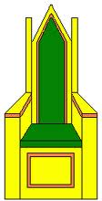
That is the picture being painted for us in chapters 4 & 5 of Revelation. The question of where is the center of the universe is answered here. The center of the universe is God Almighty’s throne room where He sits and governs over the entire universe. That throne room is spectacular in its beauty. And all who surround it are in awe of the glory and power and majesty of the One who sits on that throne.
Throne
Cherubim
24 Elders
Angels
All other creatures
The Universe
Last week we were introduced to those who surround the throne. First we saw the four living creatures, that is, the four cherubim who have unique characteristics but also many of the same as angels. They are bold, strong, intelligent and swift. They serve the Lord God and His church day and night.
Second, we saw the twenty-four elders each sitting on their own thrones. They, too, surround the throne and follow the lead of the cherubim in offering worship and praise to the Almighty. The twenty-four elders represent all the redeemed, including those who placed their trust in God prior to Christ’s first coming and those who have trusted in Christ since His first coming.
As we venture into chapter 5 this morning, we will be introduced to yet two more groups who surround the throne of God. Third will be the multitudes of angels. And fourth will be all other creatures in the entire universe. Thus, the picture of Revelation 4 & 5 shows that Almighty, Triune God rules over all.
I would like to go back to the beginning of chapter 4 and read through both chapters 4 & 5. I may add a few comments along the way, but will attempt to keep moving through these two chapters that paint a life-changing picture.
Keep in mind this is Section 2 in the book, covering chapters 4-7. These chapters comprise a slice of history from Christ’s first coming to His second coming. While this slice is taking place, so is the history of the seven churches in Section 1. They are in need of the encouragement from this picture in chapters 4 & 5 as much as we are.
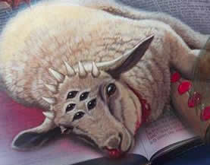
Also remember that these are visions that John sees. They are like motion pictures that he is given by the Spirit of God. He then puts in writing what he saw in these visions. These visions are laden with symbols and we must keep that in mind as we read from this book. For instance, a lamb with seven horns and seven eyes is symbolic of a leader with ultimate power and vision. Nothing escapes His notice or oversight. Jesus is symbolically a lamb. He was like a lamb in His being a sacrifice for our sins. Horns symbolize might and authority. Seven symbolizes completeness. Thus, Christ, who is a leader with ultimate power and vision, is symbolized by a lamb with seven horns and seven eyes. Jesus does not have seven horns or seven eyes. Those descriptions are symbolic.
Further, in a vision, we can feel like we are an active part of what we are seeing, though in reality our physical body remains quite attached to terra firma or in the bed in which we are sleeping as we see the vision. But, if it is truly God who is revealing the vision to John, what he is seeing points to reality, even if it is full of symbols.
And now, with appropriate fanfare, the vision of John being invited to come up to heaven and look at what must take place “after this.”
Revelation 4:1-11 (NIV96)
¹ After this I looked, and there before me was a door standing open in heaven. And the voice I had first heard speaking to me like a trumpet said, “Come up here, and I will show you what must take place after this.” ² At once I was in the Spirit, and there before me was a throne in heaven with someone sitting on it. ³ And the One who sat there had the appearance of jasper and carnelian. A rainbow, resembling an emerald, encircled the throne.
The voice is of the ascended, glorified, Jesus Christ. The One sitting on the throne is God the Father Almighty.
⁴ Surrounding the throne were twenty-four other thrones, and seated on them were twenty-four elders. They were dressed in white and had crowns of gold on their heads. ⁵ From the throne came flashes of lightning, rumblings and peals of thunder. Before the throne, seven lamps were blazing. These are the seven spirits of God. ⁶ Also before the throne there was what looked like a sea of glass, clear as crystal.
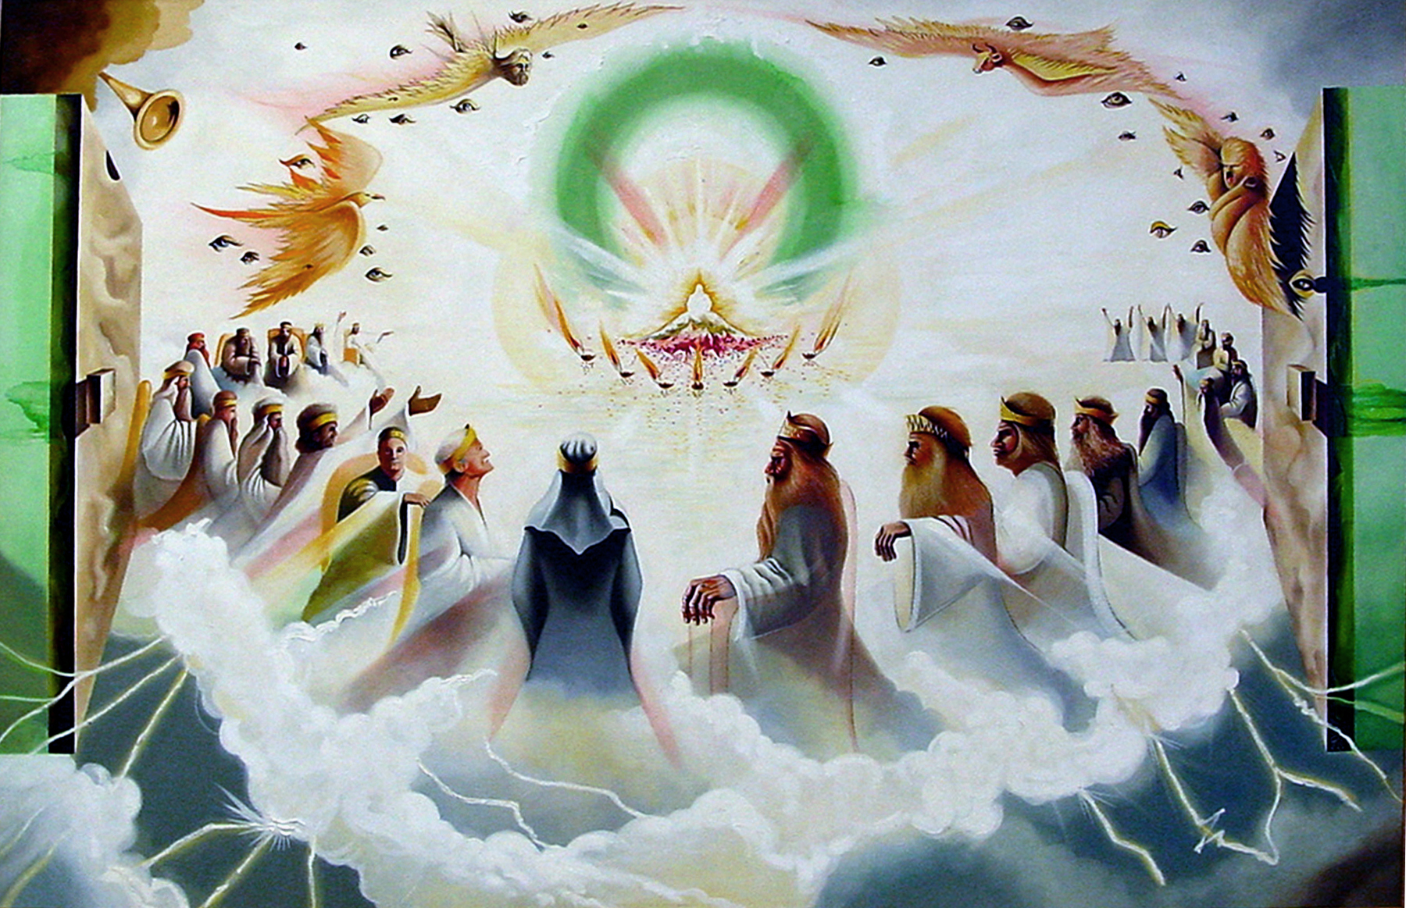
The twenty-four elders are the representatives of all the redeemed saints of all time. They personally understand the value of Christ’s redeeming work on the cross. They are surrounding the throne only because of what Christ has done for them.
In the center, around the throne, were four living creatures, and they were covered with eyes, in front and in back. ⁷ The first living creature was like a lion, the second was like an ox, the third had a face like a man, the fourth was like a flying eagle. ⁸ Each of the four living creatures had six wings and was covered with eyes all around, even under his wings. Day and night they never stop saying:
“Holy, holy, holy is the Lord God Almighty, who was, and is, and is to come.”
The four living creatures are cherubim, servants of God and His church.
⁹ Whenever the living creatures give glory, honor and thanks to Him who sits on the throne and who lives for ever and ever, ¹⁰ the twenty-four elders fall down before Him who sits on the throne, and worship Him who lives for ever and ever. They lay their crowns before the throne and say:
¹¹ “You are worthy, our Lord and God, to receive glory and honor and power, for You created all things, and by Your will they were created and have their being.”
Every time the living creatures give glory to God, the twenty-four elders follow suit. In this time of worship, they are worshipping God as Creator of all things. The notebook insert you received this morning has a page that shows how our observance of Sabbath-rest points to our eternal rest and worship in heaven. You will also see how the focus of worship in chapter 4 moves from the God of Creation to the Lamb of Redemption in chapter 5.
Revelation 5:1-14 (NIV96)
¹ Then I saw in the right hand of Him who sat on the throne a scroll with writing on both sides and sealed with seven seals. ² And I saw a mighty angel proclaiming in a loud voice, “Who is worthy to break the seals and open the scroll?” ³ But no one in heaven or on earth or under the earth could open the scroll or even look inside it. ⁴ I wept and wept because no one was found who was worthy to open the scroll or look inside.
Suddenly are attention is drawn to this locked-up scroll. But, before we even begin to think about the scroll, we need to take notice in whose right hand the scroll rests. The scroll is in God’s hand. It is likely the strongest clue we have that God is responsible for what is written on it and in it.
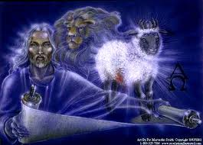
A mighty angel, surely in obedience to the Father’s command, asks the most significant question of all eternity. “Who is worthy to break the seals and open the scroll?” God wants this scroll opened. But not just anyone can open it. Only someone worthy can open it. And when the report comes back that no one in heaven or on earth or under the earth could open the scroll, John is overcome with grief as if all hope for rescue was gone. History must indeed have no meaning. We are all living a pointless existence. Let us eat, drink and be merry, for tomorrow we die. For the scroll to not be opened would mean that God’s plan for the universe would go unrevealed and unexecuted.
⁵ Then one of the elders said to me, “Do not weep! See, the Lion of the tribe of Judah, the Root of David, has triumphed. He is able to open the scroll and its seven seals.”
⁶ Then I saw a Lamb, looking as if it had been slain, standing in the center of the throne, encircled by the four living creatures and the elders. He had seven horns and seven eyes, which are the seven spirits of God sent out into all the earth.
Could it be that Jesus Christ is worthy to open the scroll? Would His triumph over sin and death and the devil be the qualification needed to be able to open the scroll? John’s hope is renewed. Maybe after all, life is not meaningless. Maybe God’s righteousness will yet prevail.
⁷ He came and took the scroll from the right hand of Him who sat on the throne. ⁸ And when He had taken it, the four living creatures and the twenty-four elders fell down before the Lamb. Each one had a harp and they were holding golden bowls full of incense, which are the prayers of the saints. ⁹ And they sang a new song:
“You are worthy to take the scroll and to open its seals, because You were slain, and with Your blood You purchased men for God from every tribe and language and people and nation.
¹⁰ You have made them to be a kingdom and priests to serve our God, and they will reign on the earth.”
What boldness on the Lamb’s part. He took the scroll. There’s nothing timid at all in that action. It’s assertive. It’s confident. It’s forceful. He came to the throne, face to face with Almighty God, and He took the scroll.
It was a public action for all those surrounding the throne to see. It was a spectacle. John’s great sorrow turned to joy. And heaven burst into song. For Jesus Christ, the Lion and the Lamb, was worthy to open the scroll because by His blood He had purchased men for God from every tribe and language and people and nation.
And just as we needed Christ to come to us in human flesh in order for us to comprehend God Almighty, so now we need Him to open this scroll and bring to pass the plan of God. No one in the entire universe was able to do what only Christ could do. It’s as though the job was put out for all potential candidates to submit their applications for this job. But no one could be found who qualified. Until, in dramatic fashion, an elder who had been redeemed by Christ, testified that he knew of someone who was qualified. And indeed, He was.
¹¹ Then I looked and heard the voice of many angels, numbering thousands upon thousands, and ten thousand times ten thousand. They encircled the throne and the living creatures and the elders. ¹² In a loud voice they sang:
“Worthy is the Lamb, who was slain, to receive power and wealth and wisdom and strength and honor and glory and praise!”
So, adding to the ongoing, triumphant song of praise from the elders and cherubim that Christ was found worthy, all the angels in multiplied numbers joined in declaring in a loud voice a seven-fold praise. These angels expressed the ultimate of praise to Christ. They stated that no one could ever receive such complete worship as Christ. He alone was qualified to open the scroll. The search had been complete and Christ alone was found worthy. There was no one else. No one else. Do we grasp the significance of this?
¹³ Then I heard every creature in heaven and on earth and under the earth and on the sea, and all that is in them, singing:
“To Him who sits on the throne and to the Lamb be praise and honor and glory and power, for ever and ever!”
¹⁴ The four living creatures said, “Amen,” and the elders fell down and worshiped.
Whatever was in the scroll, those who had been redeemed by Christ’s blood, understood that the arrival of Jesus in heaven to step up to the throne and take the scroll from His Father’s hand after having been crucified for their sins, resurrected in power to new life and now ascended to glory, understood that for Christ to take the scroll meant that God’s eternal plan would be fulfilled. Hope was secured by Christ being worthy.
Regarding the scroll, George Ladd says, “What simpler or more sublime way of picturing God’s ultimate sovereignty over all history could be found than this picture of the scroll resting in the hand of God? However strong evil becomes, however fierce be the satanic evils that assail God’s people on earth, history still rests in God’s hands.”
William Hendriksen believes “The scroll reveals God’s complete plan and purpose for the entire world throughout the ages from beginning to end. For us, the scroll with its seals is evidence of what God planned for the salvation of His people.”
Richard Bewes writes: The scroll contains “the secrets of our world’s affairs and its history.”
Again, George Ladd says: The scroll “contains the prophecy of the end events, including both the salvation of God’s people and the judgment of the wicked. It is God’s redemptive plan for . . human history, the overthrow of evil, and the gathering of a redeemed people to enjoy the blessings of God’s rule.”
Folks, we are overcomers when we are in Christ. That’s how John says this in his letters.
1 John 4:4 (NIV96) ⁴ You, dear children, are from God and have overcome them, because the one who is in you is greater than the one who is in the world.
1 John 5:3-5 (NIV96) ³ This is love for God: to obey His commands. And His commands are not burdensome, ⁴ for everyone born of God overcomes the world. This is the victory that has overcome the world, even our faith. ⁵ Who is it that overcomes the world? Only he who believes that Jesus is the Son of God.
Revelation 3:21 (NIV96) ²¹ To him who overcomes, I will give the right to sit with Me on My throne, just as I overcame and sat down with My Father on His throne.
Revelation 5:5 (NIV96) ⁵ Then one of the elders said to me, “Do not weep! See, the Lion of the tribe of Judah, the Root of David, has triumphed (overcome). He is able to open the scroll and its seven seals.”
Christ’s conquering or overcoming of evil becomes our conquering or overcoming as we live in surrender to Him.
Folks, today we have real hope that nothing that comes our way has the power to dethrone Christ from His position of worthiness. Jesus Christ cannot be dethroned! And His victory is our victory if we surrender ourselves to Him, if we remain in Him, if we believe in Him. Paul says in Romans 8:37 (NIV96) ³⁷ No, in all these things we are more than conquerors through Him who loved us.
When we surrender to Jesus Christ as Lord of our lives, we are united with Him in such a way that, spiritually speaking, we die with Him on the cross and are raised with Him to a new life with Him. But, our union with Him is not just for our earthly existence. But, we are even united with Christ in His ascension. Again, spiritually speaking, we are reigning with Christ right now as He rules this universe from His throne.
Ephesians 2:4-7 (NIV96) ⁴ But because of His great love for us, God, who is rich in mercy, ⁵ made us alive with Christ even when we were dead in transgressions—it is by grace you have been saved. ⁶ And God raised us up with Christ and seated us with Him in the heavenly realms in Christ Jesus, ⁷ in order that in the coming ages He might show the incomparable riches of His grace, expressed in His kindness to us in Christ Jesus.
Therefore, we are able to live our lives here on earth as victors, as overcomers, as conquerors through Christ who has won the victory for us.
The life Christ calls us to live is the life of total and full surrender to Him as our Redeemer and Lord. Our lives no longer belong to us. Anytime we take control of the reigns, we are creating a crisis of Lordship. We are diminishing in our minds, in our thinking, who Christ is in reality and truth. Revelation 4 & 5 teach us that Christ is the only one in all the universe worthy to rule and reign over it, including ruling and reigning over our personal lives.
Let me ask, how much of our lifestyle do we excuse with the rationalization that we think we really don’t need to obey Christ in one or more particular areas? We honed our arguments so well that we’ve convinced ourselves that we’re doing just fine.
How much of our schedule is filled with activities for which we never even consult with our Lord as to whether He even wanted us doing them in the first place? Or, how much activity does not even show up in our schedules because we either refuse to do what He is asking of us or we simply fail to sit with Him each day for a time of consultation to read His heart, to hear Him speak or to commune with Him as a son or daughter or partner in His mission to this world?
Revelation 4 & 5 is intended to get us thinking rightly about who Jesus Christ truly is and establish for us that He has every right in the universe to rule and reign over it. And Jesus Christ has every right to expect from us obedience as evidence of our love and gratitude for setting us free and making us to be a kingdom and priests to serve His God.
So, I think we need to face up to one very serious question. What keeps us from living lives that are fully surrendered to Jesus Christ? I know it’s tempting to slough off this question because we can’t think of anything we’re doing that is displeasing to Christ. But that may be because we are not practicing the discipline David did in his prayer in Psalm 139:23-24 (NIV96) ²³ Search me, O God, and know my heart; test me and know my anxious thoughts. ²⁴ See if there is any offensive way in me, and lead me in the way everlasting.
As we learned from our study of the seven churches in chapters 2 & 3, Jesus Christ is not bashful about confronting us when we are not living fully surrendered lives to Him. He truly wants us living the life of a conqueror, of an overcomer. He doesn’t want us enslaved to habits that sideline us from being His frontline warriors. He doesn’t want us dull in our thinking so that we can’t hear His voice. He doesn’t want us running away from challenges or acting like cowards, giving Him no opportunity to display His power in our lives. He wants us fully surrendered to Him so that we can reign with Him on this earth right now, living the Good News of Jesus Christ and bringing it to our neighbors, friends and family. Christ knows that we cannot be conquerors unless we live in Him through surrender.
Folks, Christ is saying to us who have given our lives to Him, “you have already begun your life with Me in heaven and that is your final destination. Live every day of your earthly life now from that perspective. Make your decisions and choices from the view of your heavenly home. Develop your relationships here on earth with heaven on your mind.
Earth as we know it is but our temporary dwelling place. The new heaven and the new earth will be our eternal home. The test we face while here on earth is whether we will be overcomers of the enemy who temps us to be idolaters, placing something else in the position only Christ should hold in our lives. And the question that the Book of Revelation is asking of all of us, are we going to be conquerors or idolaters? Are we going to be overcomers of evil or enslaved by the lies of the devil? Are we going to be victorious in Christ or defeated by Satan?
We live on a battlefield every day. Our leader, Jesus Christ, is a warrior, going out to conquer on our behalf – but we must be surrendered to Him. We must be united with Him so that His victory becomes our victory.
If we see the reality of the picture painted for us in Revelation 4 & 5, we will have every reason we need to stay surrendered to Jesus Christ who rules the universe with His Father from their throne in heaven.

George Ladd, A Commentary on the Revelation, Eerdmans, Grand Rapids, Michigan, 1972, p. 83
Kistemaker, S. J., & Hendriksen, W. (1953-2001). Vol. 20: New Testament commentary : Exposition of the Book of Revelation. Accompanying biblical text is author's translation. New Testament Commentary (202). Grand Rapids: Baker Book House.
Richard Bewes, The Lamb Wins, Creative Focus Publications, Ross-shire, Great Britain, 2000, p. 47
George Ladd, A Commentary on the Revelation, Eerdmans, Grand Rapids, Michigan, 1972, p. 81

