Sunday, December 9, 2012 – New Heights Christian Church, Kent, WA – Dr. Daniel Folden
Who is Christ?
Who is Christ FOR us in the invasion of His incarnation?
Philippians 2:5-11; Isaiah 9:1-7; Hebrews 1:1-2:18; Galatians 3:26-4:7
Hebrews 2:17 (NIV84) ¹⁷ For this reason He had to be made like His brothers in every way, in order that He might become a merciful and faithful high priest in service to God, and that He might make atonement for the sins of the people.
-----------
What you believe about Jesus Christ is the single most significant belief you hold. More than any other belief, what you believe about Jesus Christ shapes who you are and where you are heading. Jesus Christ is that significant in your life whether you acknowledge Him as Lord or not. In His own words from John 14:6 (NIV84) ⁶ Jesus answered, “I am the way and the truth and the life. No one comes to the Father except through Me.
This is His claim. If we want a relationship with our Creator, God the Father, it can only happen by having a relationship with His Son, Jesus Christ.
Now I am of the belief that all of us have at least some desire to know our Creator and experience life as He intended it to be like. I also understand that all humans are handicapped in their ability to see that desire achieved because we are children of Adam and carry about within us a resistance to our Creator. Isaiah tells us of this problem and also tells us of the solution. Isaiah 53:6 (NIV84) ⁶ We all, like sheep, have gone astray, each of us has turned to his own way; and the Lord has laid on Him (Christ, the Lamb of God) the iniquity of us all.

This season of the year when we celebrate the birth of Jesus Christ, our Savior, it’s appropriate for us to give serious thought about Who Christ is. Last week I invited you to join me in thinking about who Christ is TO us in the context of His existing, ongoing relationship within the Trinity? I was quick to admit that such a discussion walks us right into one of the greatest mysteries that exists, greater than the mystery of eternity itself. Yet, even though Triune God is a great mystery, the Bible has much to say about the community that exists between three distinct persons, God the Father, God the Son and God the Holy Spirit. Though they are distinct from each other, they are yet one God.
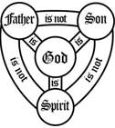
The Bible makes it clear that these are the three persons of the Godhead. And we call the Godhead the Trinity. Jesus referred to these three persons in His commissioning of His disciples to go make more disciples. Matthew 28:19 (NIV84) ¹⁹ Therefore go and make disciples of all nations, baptizing them in the name of the Father and of the Son and of the Holy Spirit,…

It was important, last week, for us to understand something of the way these three relate to and with each other so we could answer the question, how does Christ’s relationship within the Trinity impact who He is TO us?
What we saw about the relationships among the members of the Trinity was a beautiful community of agreement and cooperation. No one member acts independently of the others. They each bring honor to the others. When one is doing a task, the other two are encouraging and complementing His work. The Trinity has great love for each other and together extends that love towards their creation, particularly the humanity they created.
We also took note that the members of the Trinity serve in different roles. I mentioned that the Father is the source of all our hope, the Son is the theme of all our hope and the Spirit is the witness and fulfiller of all our hope. That is demonstrated when the Holy Spirit takes everything that the Father has given to the Son and reveals them to us. We saw that clearly in John 16:15 where Jesus was speaking to His disciples on the night before He was crucified. John 16:15 (NIV84) ¹⁵ All that belongs to the Father is Mine. That is why I said the Spirit will take from what is Mine and make it known to you.
When Jesus was living here on the earth, He was a display of the invisible God. Who Jesus is was defined by His relationship with His Father. He boldly told the Philip, … John 14:9–10 (NIV84) ⁹ … “Don’t you know Me, Philip, even after I have been among you such a long time? Anyone who has seen Me has seen the Father. How can you say, ‘Show us the Father’? ¹⁰ Don’t you believe that I am in the Father, and that the Father is in Me? The words I say to you are not just My own. Rather, it is the Father, living in Me, who is doing His work.
Jesus is so fully God, that to walk away from Him is to walk away from God.
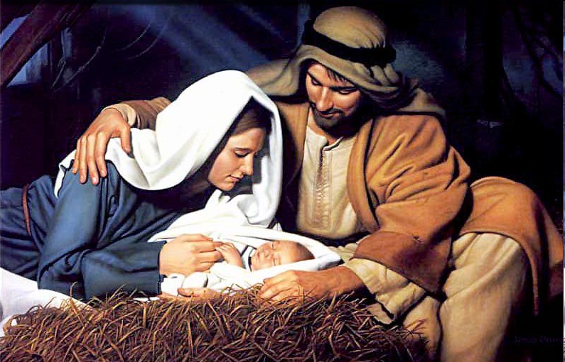
So, who is Christ TO us? He is God TO us. He is the human face of God TO us. He is the means by which we can know God and come into a relationship with Him. In fact, He is the only means for us to know God personally and intimately.
Today we move to the second of seven questions: Who is Christ FOR us in the invasion of His incarnation?
Christmas is certainly the time when we turn our attention to the coming of Christ as a babe, born in Bethlehem, born to the virgin Mary. We celebrate Christ’s coming to earth. We sing songs that speak of God being with us in the human body of Jesus.

So today, I want us to think a bit more deeply on the subject of Who Christ is FOR us by His breaking into the human race by taking on our flesh.
The Apostle Paul speaks of Christ’s incarnation, His taking on of human flesh, by way of encouraging us to live life with the same attitude that motivated Him to become human. Christ wasn’t always human. But He has always been God. Ralph Earle in The Expositor’s Bible Commentary on 1 Timothy says this: The eternal Son of God, existing as pure spirit, was made visible, was manifested, in His incarnation.
In other words, Jesus added to His spiritual nature a human body. But to do that He needed to humble Himself, like a king who would go and live in the slums of a city he rules over. He would live with those people and among those people and enter into the same struggles those people had. He would become one of them while still being their king.
Here’s how Paul says it in Philippians 2:5-11 (NIV84) ⁵ Your attitude should be the same as that of Christ Jesus: ⁶ Who, being in very nature God, did not consider equality with God something to be grasped, ⁷ but made Himself nothing, taking the very nature of a servant, being made in human likeness.
⁸ And being found in appearance as a man, He humbled himself and became obedient to death— even death on a cross!
Jesus, being in very nature God … was made in human likeness. Jesus brings human nature and the Godhead together in one single human being who will live and reign forever. This merger of humanity and deity had never happened before. The closest to it happening again will be when believers in Christ are glorified and receive their new bodies to be like Jesus. But I don’t understand that likeness to be that we will be God. Here I admit I am still a learner.
You see, Jesus adds to Himself our humanity without losing any of His deity. But, that doesn’t mean that when we receive our glorified bodies that we will be adding deity to our humanity. I understand that Jesus will continue to be our mediator in heaven. I believe that because of what Hebrews 7:3 says. Speaking of the mysterious priest-king Melchizedek of the Old Testament, who is at least a type of Christ if not the pre-incarnate Christ, we read in Hebrews 7:3 (NIV84) ³ Without father or mother, without genealogy, without beginning of days or end of life, like the Son of God he remains a priest forever. So, it wouldn’t make sense that we would be gods in heaven and still need a priest to mediate for us.
But what did it mean for Jesus to take on human flesh? By taking on flesh, God’s Son actually renounced any claim to final control over His own destiny. He placed Himself at the Father’s disposal, to do His will, to become for Him, and for us, Isaiah’s “Servant of the Lord”. That is, the suffering servant who was pierced for our transgressions and crushed for our iniquities (Isaiah 53:2-6).
But we all know that’s not the end of the story of Jesus’ life. The mission He was sent on by His Father and with the Spirit’s empowering, was to win a victory over the devil and proclaim release to those in bondage to his deceits. And because of Christ’s humble obedience, not only in taking on human flesh but willingly offering Himself as the sacrificial lamb for the sins of the world, His Father honored Him and called on every person who had ever lived and will live to worship Him.
Paul says it this way: ⁹ Therefore God exalted Him to the highest place and gave Him the name that is above every name, ¹⁰ that at the name of Jesus every knee should bow, in heaven and on earth and under the earth, ¹¹ and every tongue confess that Jesus Christ is Lord, to the glory of God the Father.
So, what starts with Jesus humbly taking on human flesh which brings Him to the cross to die, finally leads to His Father exalting Him to the highest place and giving Him the name that is above every name so that He is worshiped by everyone to the glory of God.
I point this out to say that there are four dimensions of Who Christ is FOR us in the context of our mission as a church. Those four dimensions have as their book ends the humility of the incarnation and the exaltation of the coronation. In the person of Jesus is merged these two: the human with the divine, the humility of the incarnation with the supremacy of being Lord of the universe. It’s this merger in Christ that makes Him the ultimate hope FOR us. “No other being in the entire universe brings human nature and the Godhead together like this, in one single human being.”
When Paul wrote his first letter to Timothy, he spoke of Christ as being the great mystery of godliness. Thus, Paul reminds us when we set out to learn more of Christ, we enter territory that is filled with mystery, filled with the supernatural, yet brought down to us so we can enter into the riches of the mystery He is. That is the purpose of His taking on human flesh, so through Him we might enter into eternal life and awe inspiring relationship with Triune God.
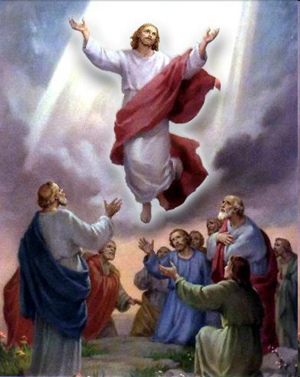
Here are the four dimensions of Christ that Paul highlights in 1 Timothy 3:16 (NIV84) ¹⁶ Beyond all question, the mystery of godliness is great: (1) He (God the Son) appeared in a body, (2) was vindicated by the Spirit, (3) was seen by angels, (5) was preached among the nations, (6) was believed on in the world, (4) was taken up in glory.
When you attempt to place these events in chronological order, it appears that the activities of “preached among the nations” and “believed on in the world” are out of order. But, these are the words to a hymn that the early church sang. In outline form, it’s much like the contemporary song In Christ Alone. In Christ alone, who took on flesh (1. Jesus’ incarnation); 'Til on that cross as Jesus died (2. Jesus’ crucifixion); Then bursting forth in glorious day (3. Jesus’ resurrection); And as He stands in victory (4. Jesus’ ascension).
That same outline is found here in 1 Timothy 3:16. But, instead of being a hymn about Christ’s life written in the context of being given the reason why we will stand “firm through the fiercest drought and storm,” the hymn that Paul quotes is in the context of the mission of the church to preach the gospel and see the power of God bring people to belief in Christ as a result.
¹⁶ … He (God the Son) appeared in a body, | 1. Jesus’ incarnation
was vindicated by the Spirit, | 2. Jesus’ crucifixion – including the totality of Jesus’ ministry to the cross
was seen by angels, | 3. Jesus’ resurrection
was taken up in glory. | 4. Jesus’ ascension
was preached among the nations,  was believed on in the world, | The church’s outward mission and the ingathering of believers
So, when we think of Who Christ is FOR us, our focus is on four aspects of His life as they impact our mission in the world. Each aspect is integrally tied to and dependent on the others. Because of time and also wanting to give focus as we celebrate the Advent of Christ at Christmas time, our attention will be primarily on Christ’s incarnation.
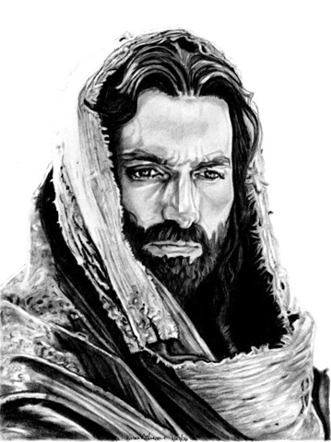
Here, then, are three very interrelated questions that I am asking of the texts we have looked at and will now look at. 1. Why did Jesus have to become human? 2. What does it mean to us that Jesus is now both human and divine? And, 3. What does it mean to Triune God that Jesus is now both human and divine?
Let’s start with the first chapter of Hebrews. Keep those three questions in mind as I read. Hebrews 1:1–4 (NIV84) ¹ In the past God spoke to our forefathers through the prophets at many times and in various ways, ² but in these last days He has spoken to us by His Son, whom He appointed heir of all things, and through whom He made the universe.
One of the roles that Jesus plays when He comes to earth as God incarnate is the role of a prophet. The prophets in the past spoke on behalf of God by the inspiration of God. Now, Jesus comes as the final Word of God and He embodies that Word in all its fullness, richness and multiplicity. God the Son remains God as He takes on humanity.
³ The Son is the radiance of God’s glory and the exact representation of His being, sustaining all things by His powerful word. After He had provided purification for sins, He sat down at the right hand of the Majesty in heaven. ⁴ So He became as much superior to the angels as the name He has inherited is superior to theirs.
Notice the word IS in verse 3. The Son IS the radiance of God’s glory. As God in the flesh, Jesus didn’t cease being God. Rather, He radiated God’s glory. The Son’s radiance, therefore, is an extension of (the Father’s) God’s glory.
Don’t think of Jesus as the moon in relation to the sun. The moon has no light of its own but simply reflects the light of the sun. Jesus, however, radiates the light of His Father. He doesn’t reflect the light, He possesses the light and radiates it and He does so as a man. Further, while being the God-Man, Jesus continues to sustain all things by His powerful word. And while continuing to be God, He goes to the cross to die for us, to “provide purification for sins.” This is what Christ is FOR us through His invasion of His incarnation. When He went to the cross as the Lamb of God, God was able to righteously lay on Him the sins of the world. It was a legal transfer made possibly only because God became like one of us. Ponder this: All that Christ has done FOR us could only come about, first of all, by being UNITED to us and COMING AMONG us, to be WITH us, as ONE of us. (pause)
We jump over several exceptionally instructive verses to get to chapter 2 and verse 10. From chapter 1, where the writer emphasized Christ’s divinity, now in chapter 2, he stresses His humanity.

Hebrews 2:10 (NIV84) ¹⁰ In bringing many sons to glory, it was fitting that God, for whom and through whom everything exists, should make the Author of their salvation perfect through suffering.
Who is the Author of their salvation? It’s Jesus. And in order for Him to be the Author or Leader of salvation, He had to achieve the purpose for which He came. That is the meaning of perfect here. By humbly and obediently going to the cross to die for our sins, He was made perfect, He fully completed the assignment He was given by His Father. As a result of His obedience, Jesus brought many sons to glory.
Hebrews 10:11–14 (NIV84) ¹¹ Day after day every priest stands and performs his religious duties; again and again he offers the same sacrifices, which can never take away sins. ¹² But when this Priest had offered for all time one sacrifice for sins, He sat down at the right hand of God. ¹³ Since that time He waits for His enemies to be made His footstool, ¹⁴ because by one sacrifice He has made perfect forever those who are being made holy.
Jesus could only achieve this objective by first becoming human and then becoming both the Priest and the sacrifice that would take away our sins. And when He did that through the unfathomable suffering on the cross, His sacrifice made perfect forever those who are being made holy.
What happened to our relationship to Triune God because of Christ’s obedience in becoming human and giving His life as a ransom for our sins? We became His brothers. We were made members of the same family. Christ is our brother and our Advocate to the Father.
Hebrews 2:11–18 (NIV84) ¹¹ Both the one who makes men holy and those who are made holy are of the same family. So Jesus is not ashamed to call them brothers. ¹² He says, “I will declare Your name to My brothers; in the presence of the congregation I will sing Your praises.”
¹³ And again, “I will put My trust in Him.”
And again He says, “Here am I, and the children God has given Me.”
What does it mean to Triune God that Jesus is now both human and divine? There is now a family of brothers and sisters of Christ who belong to Triune God. Because of Jesus’ obedience, God has bound Himself up with us humans forever – never to turn back!
¹⁴ Since the children have flesh and blood, He too shared in their humanity so that by His death He might destroy him who holds the power of death—that is, the devil— ¹⁵ and free those who all their lives were held in slavery by their fear of death. ¹⁶ For surely it is not angels He helps, but Abraham’s descendants.
Jesus’ incarnation also made possible His ministry – from birth to crucifixion to resurrection to ascension. His was and is a ministry for us that continues to this very hour, including His triumphant revolt against and defeat of the forces of darkness that plague our planet.
The diagram I presented to you showing the genuine, Holy Trinity in relation to the community called the Body of Christ, the church, is significantly relevant to our discussion. There’s something that the devil knows that many a believer in Christ seem ignorant of. The devil knows how good and rich and attractive is Christ’s community, Christ’s family of brothers and sisters when those brothers and sisters are fully surrendered to their Lord. So, because Satan knows how attractive genuine Christian fellowship and community is, he works hard to create counterfeit communities. His advertisements highlight claims that can even sound almost too good to be true. And, those tantalizing invitations to community don’t just go to the unbelieving world. They are sent out to members of Christ’s family.
Are you hearing me? Is this ringing true? Have you ever wondered why you have to fight your way into participating in genuine Christian community? It’s because we have an enemy whose first line of battle against us is to woo us into counterfeit communities under the false claim they will be better and more fulfilling than Christ’s community.
It is within genuine Christian communities where we are teamed up with fellow soldiers so that we can enter other worldly communities and bring the light of Christ into them. Be careful about thinking you can have an impact on a worldly community without being closely tied to a genuine Christ community.
We are deceived when we think we can live without regular fellowship in genuine Christian community. How can I say that? Because, it is rooted in who Christ is FOR us by the invasion of His incarnation. By becoming one of us, Christ elevates everything He touches about our lives, and subsumes all of it into the grand purposes of God – even our own sufferings, even our own death.
That’s why I said in my opening, what you believe about Jesus Christ is the single most significant belief you hold. More than any other belief, what you believe about Jesus Christ shapes who you are and where you are heading. Jesus Christ is that significant in your life whether you acknowledge Him as Lord or not.
¹⁷ For this reason He had to be made like His brothers in every way, in order that He might become a merciful and faithful high priest in service to God, and that He might make atonement for the sins of the people. ¹⁸ Because He Himself suffered when He was tempted, He is able to help those who are being tempted.
We have an advocate for our success in being obedient to Christ. That advocate is Christ Himself. And He has commissioned the Holy Spirit to be present with us at all times, carrying out Christ’s advocacy. When the Son of God accepted His Father’s assignment to come to earth and take on human flesh as part of His nature, He was forever changed. And, as a result, it made it possible for us to be forever changed.
The incarnation will forever mark the Lord Jesus Christ, as He continues to be one of us, among us, with us, FOR us – never to be otherwise, even when He returns in His glorious day of climactic victory.
Romans 8:29–32 (NIV84) ²⁹ For those God foreknew He also predestined to be conformed to the likeness of His Son, that He might be the firstborn among many brothers. ³⁰ And those He predestined, He also called; those He called, He also justified; those He justified, He also glorified.
³¹ What, then, shall we say in response to this? If God is for us, who can be against us? ³² He who did not spare His own Son, but gave Him up for us all—how will He not also, along with Him, graciously give us all things?
Christ is FOR us as demonstrated by His having become one of us. So in that context, let us now consider how we may spur one another on toward love and good deeds within the Christ community He has given us.

Ralph Earle, "1 Timothy" In , in The Expositor's Bible Commentary, Volume 11: Ephesians Through Philemon, ed. Frank E. Gaebelein (Grand Rapids, MI: Zondervan Publishing House, 1981), 370.
David Bryant, Christ Is All!: A Joyful Manifesto (New Providence, NJ: New Providence Publishers, 2004), 56.
Simon J. Kistemaker and William Hendriksen, vol. 15, Exposition of Hebrews, New Testament Commentary (Grand Rapids: Baker Book House, 1953-2001), 27.
Simon J. Kistemaker and William Hendriksen, vol. 15, Exposition of Hebrews, New Testament Commentary (Grand Rapids: Baker Book House, 1953-2001), 30.

