Sunday, December 23, 2012 – New Heights Christian Church, Kent, WA – Dr. Daniel Folden
Who is Christ?
Who is Christ WITHIN and AMONG us as the glory of the Father?
John 1:1-18; 2 Cor. 3 & 4; Exodus 40:33-38
John 1:14 (NIV84) ¹⁴ The Word became flesh and made His dwelling (literally, tabernacled) among us. We have seen His glory, the glory of the One and Only, who came from the Father, full of grace and truth.

-----------
Over the course of life, what I am finding is that not only do I not have all the answers, I haven’t even begun to ask all the questions. In other words, I’m still coming up with new questions, at least questions that are new to me, that perplex me and keep me in the hunt for more knowledge. Now, I hope I’m not wearying you with questions or with challenges to think, especially to think about God. Our present study that is focused on learning more about who Christ is highlights seven questions about Him; questions that hopefully are surfacing for each of us answers that are exposing and revealing more of Christ’s glory in ways we many not have previously seen.

In John’s Gospel, in the first chapter and verse 14, speaking for the believers who presumably had seen Jesus in bodily form, makes a profound statement that has caught my attention. John says of these early believers concerning Jesus, ¹⁴ … We have seen His glory, the glory of the One and Only, who came from the Father, full of grace and truth. “We have seen His glory.” John is speaking of Jesus Christ’s glory.
To confirm that John is speaking of Jesus, we simply move ahead 4 verses to v. 18 and John makes it even more clear. Notice how the translators of three versions express the same thought.
John 1:18 (NIV84) | ¹⁸ No one has ever seen God, | No one has ever seen God
John 1:18 (NASB95) | ¹⁸ No one has seen God at any time;
John 1:18 (ESV) | ¹⁸ No one has ever seen God;

John 1:18 (NIV84) | but God the One and Only, | But Jesus, who is God.
John 1:18 (NASB95) | the only begotten God
John 1:18 (ESV) | the only God,

John 1:18 (NIV84) | who is at the Father’s side, | The Son is at His Father’s side.
John 1:18 (NASB95) | who is in the bosom of the Father, | The Son is in the bosom of His Father.
John 1:18 (ESV) | who is at the Father’s side,

John 1:18 (NIV84) | has made Him known. | Jesus has made His Father known.
John 1:18 (NASB95) | He has explained Him. | Jesus has explained His Father.
John 1:18 (ESV) | He has made Him known.
Back to verse 14 and the startling statement by John. ¹⁴ … We have seen His glory, the glory of the One and Only, who came from the Father, full of grace and truth. “We have seen Jesus’ glory. We have seen God’s glory in Jesus. Jesus came from the Father. He came full of grace and truth.”
In verse 18, John expands the picture to say that Jesus, who has made His Father known and revealed the glory of the Triune God, is presently at His Father’s side. In other words, Jesus has returned to His Father. But before He returned to His Father, Jesus revealed and made known the glory that both the Father and the Son shared in as God. And John tells us that the glory that Jesus revealed was seen by John and others.
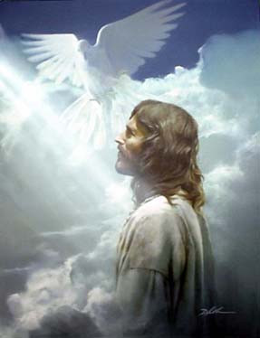
Looking at a bit more of the context for this glory that was both revealed and seen, let’s step back to include the first sentence of verse 14. John 1:14 (NIV), ¹⁴ The Word became (or was birthed with) flesh and made His dwelling (literally, tabernacled) among us.
We learn from the first four verses of chapter one that the Word or Logos co-existed with God and as God eternally from the beginning, that He, the Word, fully participated in the creation of all things, and that in Him was life and that life was the light of men.
John 1:1-4 (NIV84) ¹ In the beginning was the Word, and the Word was with God, and the Word was God. ² He was with God in the beginning. ³ Through Him all things were made; without Him nothing was made that has been made. ⁴ In Him was life, and that life was the light of men.
We know that the word Word here is Jesus. We know from our previous studies that He took on flesh. John repeats that reality in verse 14, ¹⁴ The Word became flesh and made His dwelling among us. This is at the very heart of the message for today when we ask the question: Who is Christ WITHIN and AMONG us as the glory of the Father? Why do I wrestle with this question? I want us to be able to say with John, “We have seen His glory, ….” I want this to be a present reality for us here at New Heights. Because for one, I need my eyes to be cleared of whatever is veiling Christ’s glory from me so I can say with John, “I have seen Christ’s glory.” So, if you’re wanting the same and think there’s more of Christ’s glory that is still veiled to you and that God wants you to see now, in advance of arriving in heaven, then you will also want to grapple with me on this question: Who is Christ WITHIN and AMONG us as the glory of the Father?
The question is partially answered as we review our previous three sermons. And the verses I used to review the first two in our series and introduce the third are worth meditating on once again. They’re equally as powerful and as astounding as John’s words in John 1:14.
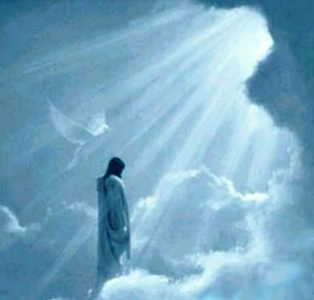
The apostle Paul startlingly declares in Colossians 2:9–10 (NIV84) ⁹ For in Christ all the fullness of the Deity lives in bodily form, ¹⁰ and you have been given fullness in Christ, who is the head over every power and authority.
“In Christ all the fullness of the Deity lives in bodily form. You have been given fullness in Christ. Christ is the head over every power and authority.” Those three statements summarize the first three sermons; Who is Christ TO us? Who is Christ FOR us? And who is Christ OVER us?

If you’re thinking at all about these words of Paul, and you believe he speaks the truth, then you and I should be stunned with amazement at the glorious majesty of Jesus Christ. These three statements leave little opportunity for thinking people to be fence sitters regarding Jesus Christ. Glory compacted in those words because they are speaking of glory that is compacted in the person of Jesus Christ.
Here is a small microchip. This is or was considered to be the world’s smallest electric motor. Microchips are now doing exponentially more in a smaller amount of time at far less the cost as they were 30 years ago. I don’t know if microchips even existed 30 years ago.


Here’s my first computer in 1983. That means, next fall it will be 30 years ago I bought my first computer at 4 times the price I paid for my latest laptop last month. It used 5 ¼” floppy disks that held a capacity of 360 KB of data, an amazing capacity of about 180 pages of plain text. 30 years ago I was very impressed with what my portable computer could do. Now my new laptop has a 700 GB hard drive; that’s over 2.1 trillion times the capacity of my first computer floppy disk. And, honestly, I don’t think I’m as impressed now as I was then, 30 years ago. But, I should be, don’t you think? The things I can do now compared to back then, are vastly greater, better and easier. It’s good to stop and consider such technological improvements.


But, the most sophisticated and most powerful computer, even a thousand years from now, doesn’t even show up on the meter when compared to the power and majesty of Triune God. His power is still on display microcosmically and macrocosmically. With the advancement of technology, we are now seeing things out into space that is nothing short of mind boggling.

Here is what NASA scientists have named Galaxy M33. They claim that “a large cloud of gas spawned dense internal knots which gravitationally collapsed to form stars.” They claim that “a vast nebula NGC 604 within the Triangulum galaxy M33 … was so large it could form enough stars to make a globular cluster.” (Image Credit: NASA)
We come back to Paul’s astounding declaration in Colossians 2:9–10 (NIV84) ⁹ For in Christ all the fullness of the Deity lives in bodily form, ¹⁰ and you have been given fullness in Christ, who is the head over every power and authority.
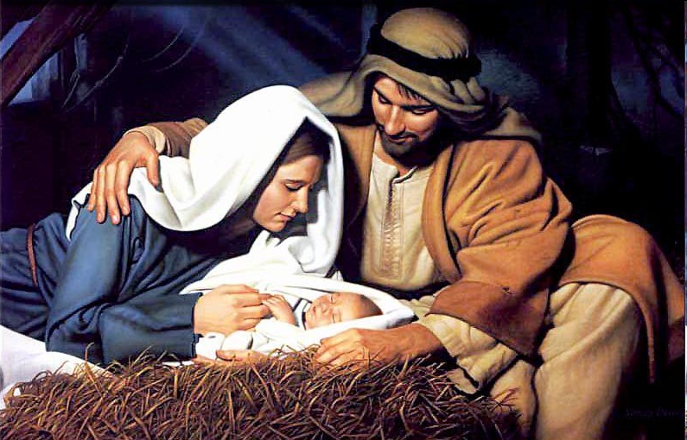

The one who fully participated in creating all of this humbled Himself and clothed Himself with humanity. Paul puts it this way: “In Christ all the fullness of the Deity lives in bodily form.” This is who Christ is TO us in the context of His existing and ongoing relationship within the Trinity. Christ brings to us the fullness of God. He is God TO us. In fact, Jesus is so fully God, that to walk away from Him is to walk away from God. He is the human face of God TO us. He is the means by which we can know God and come into a relationship with Him. Indeed, He is the only means for us to know God personally and intimately. This is who Christ is TO us in His intimacy within the Trinity.
Paul then says, “You have been given fullness in Christ.” The NASB translation says, “in Him you have been made complete.” Those of us who have by faith placed our full trust in Jesus Christ are fully complete in Him. We have been forgiven of our sins and united to Him with new life now dwelling within us. This is a result of who Christ is FOR us by His invasion into this world through His incarnation. He not only represents God TO us, He brings us into personal and intimate relationship with the Triune God through His ministry as the incarnate Son of God who sacrificially gave His life FOR us as the Lamb of God. He could only do this FOR us by becoming one of us. All the while in becoming one of us in human flesh He lost nothing of His divine nature. He remained fully God.

So, when we ask, who is Christ FOR us through the invasion of His incarnation, we answer, He is our Savior, our Redeemer. He won the battle over sin and death and the devil. And by faith in Him, we presently are enjoying the fruit of His victory.
The third truth claim that Paul makes in Colossians 2:9-10 is that “Christ is the head over every power and authority.” This, too, is an astounding statement and it answers our question, who is Christ OVER us? Paul says, there is no power or authority over which He is not Lord. Every power and authority owes its existence to Jesus, and is subject to Him at all times.
In speaking about Christ, Paul says in Colossians 1:16 (NIV84) ¹⁶ For by Him all things were created: things in heaven and on earth, visible and invisible, whether thrones or powers or rulers or authorities; all things were created by Him and for Him.
No authority exists which is not subject to the authority and rule of Jesus Christ. That answers the question: Who is Christ OVER us in the unfolding of world history?
For the remainder of our time, I’m praying that God lift the veil at least a bit for all of us to see Who Christ is WITHIN and AMONG us as the glory of the Father.
I come back to John 1:14 (NIV), ¹⁴ The Word became flesh and made His dwelling (tabernacled) among us. We have seen His glory, the glory of the One and Only, who came from the Father, full of grace and truth.
How do we see Christ’s glory? Hopefully, we see it in His relationship within the Godhead. Just being aware that even while clothed with humanity He remains God, should help us see His glory. Further, as we consider His humility in becoming like us in our humanity in order to take on our judgment levied against us for our sinfulness for the purpose of extending back to us forgiveness and mediation in order to be restored in our relationship with the Father, most certainly is a display of His glory. And to have considered His rightful position as King over all kings and Lord over all lords and head over His church, worthy to be in that position because He conquered sin and Satan and all His enemies and now resides on the throne in heaven alongside His Father, this, too, is a marvelous display of His glory.
But, today, we are asking, how does His dwelling among us, tabernacling in our midst, display His glory and the Father’s glory for us to behold?
There are two primary ways that Jesus lives among us, even today. First and most established in our thinking, is that Jesus comes to live within us personally and individually through the indwelling presence of the Holy Spirit. We emphasize this relationship most in our evangelism and, probably, even in our own thinking about where Jesus is right now. We would say, “He lives within my heart.” We think of our relationship with Christ in very personal terms. That is right and good.

But, it may come as a bit of a surprise, that much more often when the New Testament speaks about Christ being present among us or within us it is stated in the plural in the context of the community or the congregation of believers. Jesus says it succinctly in Matthew 18:20 (NIV84) ²⁰ For where two or three come together in My name, there am I with them.” Jesus promises His presence will be in the midst of His people gathered in His name. This promise, in the context of our immediate inquiry, begs the question, should we be anticipating that Christ will be revealing His glory when we are gathered in His name? Will we have eyes to see His glory? Will we have any awareness that He is truly among us?
In Paul’s second letter to the Corinthians where he is pouring out his love for this church saying, “I wrote to you … to let you know the depth of my love for you” (2 Cor. 2:4), he goes on in chapter 3 to argue that because the ministry of Moses in the Old Testament came with glory, how much more should we anticipate glory to be present in Christ’s ministry among us through His abiding presence in the Spirit.
2 Corinthians 3:9–11 (NIV84) ⁹ If the ministry that condemns men is glorious, how much more glorious is the ministry that brings righteousness! ¹⁰ For what was glorious has no glory now in comparison with the surpassing glory. ¹¹ And if what was fading away came with glory, how much greater is the glory of that which lasts!
Paul is saying that Christ’s ministry among us brings righteousness. That is a glorious ministry. In fact, in comparison to the glory of Moses’ ministry, Christ’s ministry is the surpassing glory because it’s a lasting glory.
So, Paul affirms my question: should we be anticipating that Christ will be revealing His glory when we are genuinely gathered in His name?
Paul goes on to speak of a veil that covers our faces when the old covenant is read. 2 Corinthians 3:14–18 (NIV84) The veil has not been removed, because only in Christ is it taken away. ¹⁵ Even to this day when Moses is read, a veil covers their hearts. ¹⁶ But whenever anyone turns to the Lord, the veil is taken away. ¹⁷ Now the Lord is the Spirit, and where the Spirit of the Lord is, there is freedom. ¹⁸ And we, who with unveiled faces all reflect the Lord’s glory, are being transformed into His likeness with ever-increasing glory, which comes from the Lord, who is the Spirit.

So, Christ removes the veil that covers our hearts so that His glory can transform us into His likeness giving us freedom to reflect His glory to those around us.
¹⁶ … whenever anyone turns to the Lord, the veil is taken away. ¹⁸ And we, who with unveiled faces all reflect the Lord’s glory,…
Christ removes the veil that covers our hearts so that His glory can transform us into His likeness giving us freedom to reflect His glory to those around us.

The glory that Moses had was a fading glory. Only for a short while did he need to cover or veil his face to protect people from his glory. But, Christ’s glory does not fade, but does a work of progressively transforming our lives more and more into His likeness with ever-increasing glory being reflected by our transformed lives.
Paul then tells us in chapter 4 that this transformation that Christ brings about in our lives gives us a ministry to plainly set forth the truth of the word of God in the presence of believers and unbelievers alike.
2 Corinthians 4:5–7 (NIV84)⁵ For we do not preach ourselves, but Jesus Christ as Lord, and ourselves as your servants for Jesus’ sake. ⁶ For God, who said, “Let light shine out of darkness,” made His light shine in our hearts to give us the light of the knowledge of the glory of God in the face of Christ.
⁷ But we have this treasure in jars of clay to show that this all-surpassing power is from God and not from us.
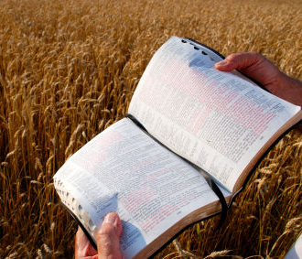
Christ, who is the light, pushes back the darkness that Satan brings upon us. The light of God’s word unveils or uncovers Christ’s glory. God’s word shines its light into our hearts driving out our blindness and allowing us to see the light that is in the face of Christ, the light that is the knowledge of the glory of God. This is what we should be expecting when we are in Christ’s presence, which should especially be when we are in a community of believers gathered in His name. As we see Christ’s glory as more and more of it is revealed to us in the Scriptures, and, as we welcome the transformation Christ’s wants to work in our lives through His presence, we as a community of progressively transformed believers in Christ will reflect Christ’s glory. And it will be obvious to those around us that it is not our glory but Christ’s because we are simply jars of clay delighting that Christ’s glory has chosen to reside within us and among us.
Now, for all that we’ve seen just in these few Scriptures, I think we can safely say that God wants a relationship with His creation and characterizing that relationship is His desire to reveal to us and through us His glory. He wants us to live in the wonder of who He is and enjoy intimacy of relationship with Him. That is why He sent us His Son and united Him with our humanity so that in all ways He could mediate our relationship with the Father.
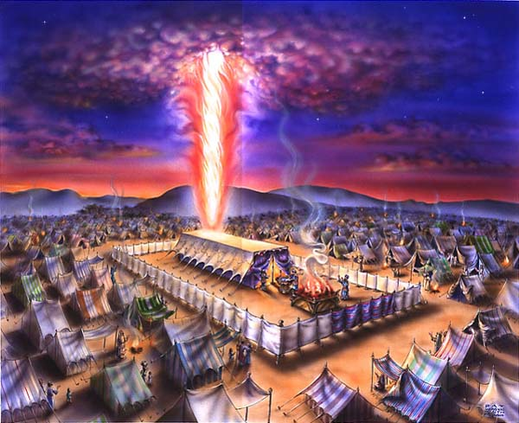
Once again, John 1:14 (NIV84), ¹⁴ The Word became flesh and made His dwelling (tabernacled) among us. We have seen His glory, the glory of the One and Only, who came from the Father, full of grace and truth.
Let’s focus on this phrase, “He made His dwelling among us.” “He tabernacled among us.” Or even more literally, “He set up His tent among us.” Now that has to remind us of the Exodus story and the role that the tabernacle played in the lives of Israel. The tabernacle, along with the pillar of cloud during the day and the pillar of fire at night, was a sign of God’s presence in the midst of Israel.
Exodus 40:33–38 (NIV84) ³³ Then Moses set up the courtyard around the tabernacle and altar and put up the curtain at the entrance to the courtyard. And so Moses finished the work.
³⁴ Then the cloud covered the Tent of Meeting, and the glory of the Lord filled the tabernacle. ³⁵ Moses could not enter the Tent of Meeting because the cloud had settled upon it, and the glory of the Lord filled the tabernacle.

³⁶ In all the travels of the Israelites, whenever the cloud lifted from above the tabernacle, they would set out; ³⁷ but if the cloud did not lift, they did not set out—until the day it lifted. ³⁸ So the cloud of the Lord was over the tabernacle by day, and fire was in the cloud by night, in the sight of all the house of Israel during all their travels.
The tabernacle and the cloud of God’s presence not only pointed to God dwelling among His people then, in their journey through the desert, but that picture described Christ’s relationship with His disciples while He was on the earth. Further, the metaphor of the tabernacle continues to describe Christ’s relationship with us presently. And even more astounding, the metaphor of the tabernacle or tent describes God the Father and the Son’s relationship with us in the kingdom to come, in the new Jerusalem, in heaven.
Revelation 7:15 (NIV84) ¹⁵ Therefore, “they are before the throne of God and serve Him day and night in His temple; and He who sits on the throne will spread His tent over them.
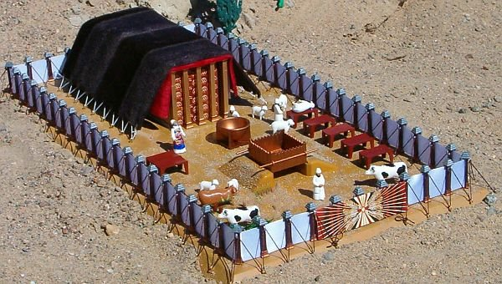
So, let me ask you. What is God saying to us by this imagery of the tabernacle? When Jesus identifies Himself as the tent that resides in the middle of the community of His people or Himself as the temple wherein His people live, what is He saying to us? Is God not saying, “I need a place to dwell among My creation. I need to be near them. I need to become like them so I can empathize with them, take their judgment for their sinfulness upon Myself so I can offer them forgiveness.”
In the Brumfield Home Fellowship this past Wednesday night, Dave summarized it well when he said this is what God is saying, “In order to redeem My creation, I must have a relationship with My creation.” (Dave Brumfield)

Christ’s ministry of redemption and reconciliation is rooted in His relationship with us. Therefore, in every congregation, every time we gather, Christ is present and Christ is presiding as King. It doesn’t matter the size of the congregation. Christ can be just as fully present in a small fellowship as in a large one. If you’re looking for a church, your first criterion must be is Christ present and is He presiding as King in that congregation? No other criterion should trump that one.
Every time we gather together, our first order of business must be this: We must be sure that with all of our hearts we give Christ His rightful place among us as the Lord He truly is, so that we might respond to Him fully as He reigns supreme in our midst, in all we do and say in His name. We must be careful never to forget that He is the purpose of our gatherings. For as we welcome Him to freely be present among us, He pulls back the veil a bit more for us to see more of His glory. In the process, the selfishness and pride that we have so carefully been protecting is exposed for the sin that it is and we are happy to confess it and let Christ replace that selfishness and pride with humility and service for His glory. And we become a bit more like Christ as a result and our congregation radiates Christ’s glory a little bit more.

