Sunday, December 29, 2013 – New Heights Christian Church, Kent, WA – Micah Adamson
Jesus, the lead defender of the Christian faith:
Practical ideas to increase the impact of the gospel in the lives of others.
Sermon Text: John 4:1-42
John 4:28-30 (NIV84) ²⁸ Then, leaving her water jar, the woman went back to the town and said to the people, ²⁹ “Come, see a Man who told me everything I ever did. Could this be the Christ?” ³⁰ They came out of the town and made their way toward Him.

John 4:1-6 (NIV84)
¹ The Pharisees heard that Jesus was gaining and baptizing more disciples than John, ² although in fact it was not Jesus who baptized, but his disciples. ³ When the Lord learned of this, he left Judea and went back once more to Galilee.
⁴ Now he had to go through Samaria. ⁵ So he came to a town in Samaria called Sychar, near the plot of ground Jacob had given to his son Joseph. ⁶ Jacob’s well was there, and Jesus, tired as he was from the journey, sat down by the well. It was about the sixth hour.

John 4:7-12 (NIV84)
⁷ When a Samaritan woman came to draw water, Jesus said to her, “Will you give me a drink?” ⁸ (His disciples had gone into the town to buy food.)
⁹ The Samaritan woman said to him, “You are a Jew and I am a Samaritan woman. How can you ask me for a drink?” (For Jews do not associate with Samaritans.)
¹⁰ Jesus answered her, “If you knew the gift of God and who it is that asks you for a drink, you would have asked him and he would have given you living water.”
¹¹ “Sir,” the woman said, “you have nothing to draw with and the well is deep. Where can you get this living water? ¹² Are you greater than our father Jacob, who gave us the well and drank from it himself, as did also his sons and his flocks and herds?”

John 4:13-18 (NIV84)
¹³ Jesus answered, “Everyone who drinks this water will be thirsty again, ¹⁴ but whoever drinks the water I give him will never thirst. Indeed, the water I give him will become in him a spring of water welling up to eternal life.”
¹⁵ The woman said to him, “Sir, give me this water so that I won’t get thirsty and have to keep coming here to draw water.”
¹⁶ He told her, “Go, call your husband and come back.”
¹⁷ “I have no husband,” she replied.
Jesus said to her, “You are right when you say you have no husband. ¹⁸ The fact is, you have had five husbands, and the man you now have is not your husband. What you have just said is quite true.”

John 4:19-26 (NIV84)
¹⁹ “Sir,” the woman said, “I can see that you are a prophet. ²⁰ Our fathers worshiped on this mountain, but you Jews claim that the place where we must worship is in Jerusalem.”
²¹ Jesus declared, “Believe me, woman, a time is coming when you will worship the Father neither on this mountain nor in Jerusalem. ²² You Samaritans worship what you do not know; we worship what we do know, for salvation is from the Jews. ²³ Yet a time is coming and has now come when the true worshipers will worship the Father in spirit and truth, for they are the kind of worshipers the Father seeks. ²⁴ God is spirit, and his worshipers must worship in spirit and in truth.”
²⁵ The woman said, “I know that Messiah” (called Christ) “is coming. When he comes, he will explain everything to us.”
²⁶ Then Jesus declared, “I who speak to you am he.”

John 4:27-30 (NIV84)
²⁷ Just then his disciples returned and were surprised to find him talking with a woman. But no one asked, “What do you want?” or “Why are you talking with her?”
²⁸ Then, leaving her water jar, the woman went back to the town and said to the people, ²⁹ “Come, see a man who told me everything I ever did. Could this be the Christ?” ³⁰ They came out of the town and made their way toward him.

John 4:31-38 (NIV84)
³¹ Meanwhile his disciples urged him, “Rabbi, eat something.”
³² But he said to them, “I have food to eat that you know nothing about.”
³³ Then his disciples said to each other, “Could someone have brought him food?”
³⁴ “My food,” said Jesus, “is to do the will of him who sent me and to finish his work. ³⁵ Do you not say, ‘Four months more and then the harvest’? I tell you, open your eyes and look at the fields! They are ripe for harvest. ³⁶ Even now the reaper draws his wages, even now he harvests the crop for eternal life, so that the sower and the reaper may be glad together. ³⁷ Thus the saying ‘One sows and another reaps’ is true. ³⁸ I sent you to reap what you have not worked for. Others have done the hard work, and you have reaped the benefits of their labor.”

John 4:39-42 (NIV84)
³⁹ Many of the Samaritans from that town believed in him because of the woman’s testimony, “He told me everything I ever did.” ⁴⁰ So when the Samaritans came to him, they urged him to stay with them, and he stayed two days. ⁴¹ And because of his words many more became believers.
⁴² They said to the woman, “We no longer believe just because of what you said; now we have heard for ourselves, and we know that this man really is the Savior of the world.”

Three Elements of Persuasion
- Ethos – (root of “ethics”), having to do with our actions or behavior
- Pathos – (root of “pathology”), having to do with the other person’s feelings or response
- Logos – (root of “logic”), having to do with reasoning or apologetic arguments for truth

William Lane Craig's 3 ways that apologetics is practical:
- For our own doubts (faith)
- For other people's doubts (evangelism)
- For our worldview (works/secondary effects of faith)

Twelve units of each cycle of apologetic sermons New Heights 2013-2014
- A1 - The will is more powerful than the mind. Why some don’t presently believe in Jesus.
- A2 - The Bible is a reliable source of truth about Jesus.
- A3 - General Revelation – What everyone knows about God.
- A4 - Jesus’ use of reason to defend His claims.
- A5 - Jesus’ use of testimony to defend His claims.
- A6 - Jesus’ use of miracles to defend His claims.
- A7 - Jesus’ use of the resurrection to defend His claims.
- A8 - Jesus’ use of parables to defend His claims.
- A9 - Jesus’ use of bold and direct claims to be God.
- A10 - Jesus’ use of prophecy to defend His claims.
- A11 - Jesus’ use of the Holy Spirit to defend His claims.
- A12 - Application: Practical ideas to make Christ’s claims known.

How (have/would you like) these topics to help you with your own doubts?
How (have/would you like) these topics to help you share you faith?
How (have/would you like) these topics to help you put your faith into practice?
MAP 1: Patriarchs
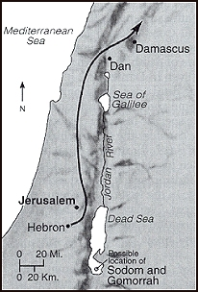
MAP 2: Land Divisions
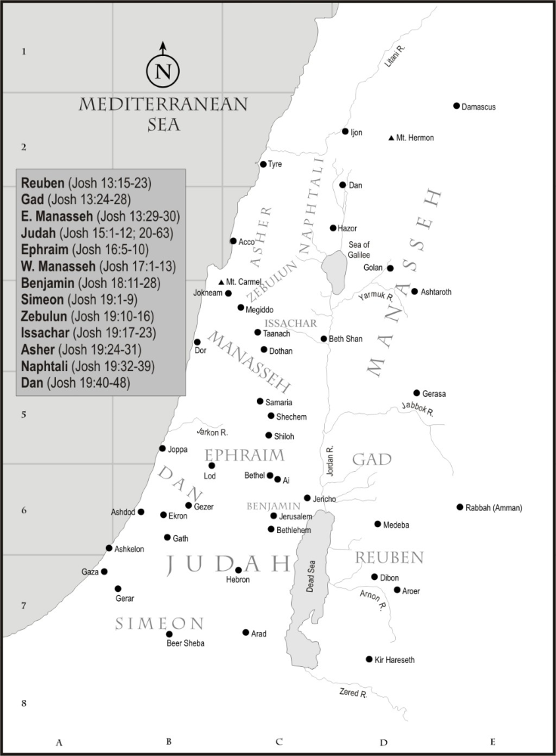
MAP 3: Divided Kingdom / Sychar (Shechem?)
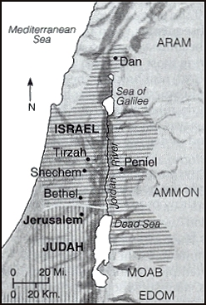
MAP 4: Israel in Jesus‘ Day
