Sunday, March 1, 2015 – New Heights Christian Church, Kent, WA – Dr. Daniel Folden
Highlights in Acts: The imperative of teaching and reasoning from the Word of God!
Acts 18:1–22
Acts 18:11 (NIV84) ¹¹ So Paul stayed for a year and a half, teaching them the word of God.
-----------
Today we will be looking at the last portion of Paul’s second missionary journey, his ministry in Corinth, Greece and his visit to Ephesus on his way back to Jerusalem and Antioch, Syria. What I have now observed in his first two missionary journeys are many things that are common in each city to which he goes as well as the unique features of each city and how those unique features impact Paul’s approach to ministry in those cities. So, there are common elements of ministry expressed in every ministry opportunity and unique elements of ministry tailored for the uniqueness of each opportunity.
Such is also the case as we think about the missionaries and missions we support as a church family. Each missionary shares the common goal to communicate the Gospel of Jesus Christ to their target audience. Yet, because each audience is different, the approach of each of our missionaries is tailored for each segment of their audience.
Michael and Marie Currier are communicating the hope of Jesus Christ by helping to bring the written and spoken word of God to people groups and languages who previously have not had a Bible in their own language.
James and Janelle Junior are making Jesus Christ known to college students at Western Washington University as the answer to all of life’s major questions including: How did this world come into existence? What is the purpose of life? What happens after we die? Why is their evil in the world? And they are tailoring their ministry to communicate to each unique person to whom they minister.
Tim & Muriel Teusink are giving Ethiopians hope in Jesus Christ as they demonstrate His love by finding Biblical and practical ways to prevent the spread of HIV and doing so in the name of Jesus Christ.
Rob and Martine Karch have recently completed ten years of ministry in French Quebec, assisting Christians in St. Jerome to plant a church that is evangelizing their community with the Gospel of Jesus Christ and planting other churches in the region.
Titus and Stephanie Folden, through the ministry of preventing the trafficking of children, are demonstrating the power and hope of the Gospel by working with churches in Guayaquil, Ecuador to obey God’s call to love and care for the most vulnerable in their community.
Amelia Erwin, through the unique ministry of Christian literature distribution at ports around the world, is bridging cultural differences to make the gospel of Jesus Christ know in the Far East.
And our newest missionary we support, Chaplain Dick Rothlisberger, goes one-on-one with inmates at our Regional Justice Center jail, sharing the gospel and engaging in weekly Bible study with inmates.
And then there’s us, those of us who participate in our mission to the Colville Indians, seeking to see the Lord open doors for sharing the Good News of Jesus Christ by first joyfully serving these dear people at their point of material need.
All of these unique ministries share in common the objective of making Christ known as the only true hope of solving our sin problem and finding real and lasting meaning in this life and the delightful answer of an eternity in the presence of Christ in the here after.
So far, none of our missionaries that I am aware of have been beaten or jailed for their work as missionaries. But I wonder how we would feel about future missionary endeavors if some of those we had sent out returned to say that they had been injured and abused by the very ones they were trying to help or encourage or share the gospel with. Would we have serious second thoughts about at least where we would be sending our missionaries next, if at all? Right?
I raise this issue to attempt to get us a bit more emotionally engaged while reading about Paul’s missionary trip. What if Paul were from New Heights Christian Church? What would be our response upon hearing of the reception he received in Pisidian Antioch, Iconium, and Lystra, or Philippi, Thessalonica or Berea? How he was attacked, verbally and physically abused and run out of town. How would we have responded? How would we have prayed?
I’m thinking about the folks in Antioch, Syria, Paul’s sending church. They not only sent Paul, they were his partners in prayer. Did they realize the danger they were sending Paul into, the risks he was taking or the viciousness of his opponents? I don’t know the answer to that. I’m guessing they sort of did.
This morning as we follow Paul as he completes his second missionary journey, let’s be asking questions and dreaming dreams about our outreach, our missionary endeavors and our connectedness to those we send out as part of our obedience to the Great Commission. Let’s also be thinking about our ministries right here in the Kent area. Is there a word of encouragement for us from Paul’s ministry in Corinth? Let’s look.
Our text takes us to the last two places in which Paul ministers at Corinth and Ephesus before returning to Jerusalem and then finally returning to his sending congregation, Antioch.
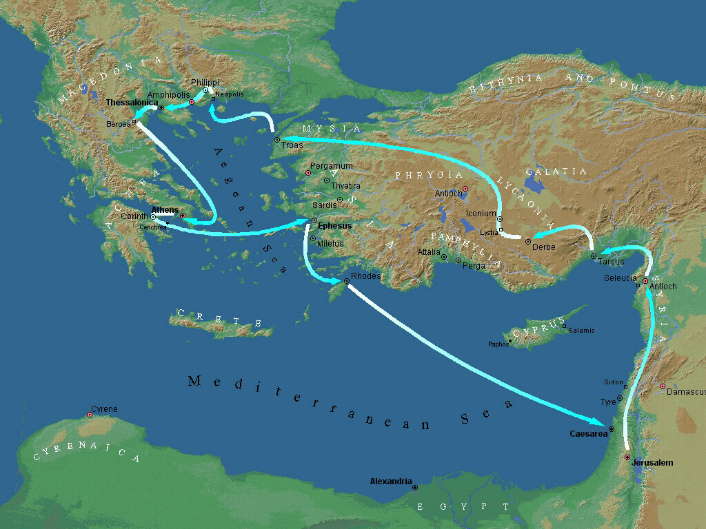
You may recall Paul’s previous stops on this second major mission’s trip. His initial mission took him into the Galatian region of Asia Minor or modern day Turkey, to Derbe, Lystra and Iconium. While in Lystra, Timothy joins Paul’s team. Paul then attempts ministries in Mysia and Bithynia but found no open doors. He crossed the Aegean Sea and went to Philippi in the Macedonia region of Greece. He had fruitful, albeit short, ministries in Philippi, Thessalonica and Berea before he was so swiftly escorted out of Berea where he left his teammates behind. While waiting in Athens for Silas and Timothy, Paul found himself almost literally carried into the Areopagus to defend and explain what he was proclaiming about Christ while in the marketplace of Athens.
In Paul’s first letter to the Thessalonians, likely written in Corinth, it appears that at least Timothy made it to Athens in response to Paul’s request, but he was shortly sent back because of Paul’s great concern that his ministry efforts in Thessalonica might all go to waste. Paul writes to the Thessalonians … 1 Thessalonians 3:5 (NIV84) ⁵ … I sent (Timothy) to find out about your faith. I was afraid that in some way the tempter might have tempted you and our efforts might have been useless.
So in essence, Paul was alone during his time in Athens. His ministry results were relatively limited and he possibly left Athens discouraged. We pick up his story in Acts 18, verse 1.
Acts 18:1 (NIV84) ¹ After this, Paul left Athens and went to Corinth.
Luke really doesn’t give us Paul’s reason for leaving Athens, at least not in these paragraphs. He wasn’t actually being forced out of Athens as he had been in Philippi, Thessalonica and Berea. Possibly he saw the hardness of heart of the people of Athens and determined his time would be better spent somewhere else.
For whatever reason he left Athens, he sets his aim for the notoriously immoral city of Corinth, the capital of Achaia, the southern half of Greece. Immorality was so pervasive in Corinth that even their religious practices were saturated with immoral rituals. Their economic prosperity as an international commercial center only fueled further immorality throughout the city. That’s the setting into which Paul arrives to bring the message of Jesus Christ, the author of life, the champion of purity in relationships. What’s his plan? Will he be alone again in this city as he was in Athens?
Acts 18:2-4 (NIV84) ² There he met a Jew named Aquila, a native of Pontus, who had recently come from Italy with his wife Priscilla, because Claudius had ordered all the Jews to leave Rome. Paul went to see them, ³ and because he was a tentmaker as they were, he stayed and worked with them. ⁴ Every Sabbath he reasoned in the synagogue, trying to persuade Jews and Greeks.
In verse 2, Luke tells us that Paul met Aquila. He doesn’t tell us how. We can speculate. The fact that both Paul and Aquila were tentmakers, gives us a possible clue. When Paul was on his own, he needed to earn some money and he would do that by making tents. So I think it’s very reasonable to think that Paul met Aquila when he went shopping for tentmaking supplies, since they were both tentmakers by trade. And in that initial meeting, they discovered of each other that they both were committed followers of Jesus Christ. Either one of them could have asked the other, “So what brought you to Corinth?” Honest answers from either one would have revealed their genuine relationship to Christ. So they had two strong bonds to bring them together.
At the end of verse 2 it says Paul went to see Aquila and Priscilla. That suggests that Aquila had a chance to break the news about Paul to his wife Priscilla and prepare their place to welcome him to stay with them.
Isn’t it delightful to see how God brings people together as friends and work associates? Aquila and Priscilla were forced to leave Rome and went to Corinth. Paul probably left Athens discouraged with the poor response of the people to the Gospel. And the Lord coincidentally and sovereignly connects Paul with Aquila and Priscilla in a city of about 200,000 people. But, however they met, either because they connected at a tentmaking supply store or they ran a bed and breakfast or a hotel service or something like that, they became the best of friends, business associates and ministry team partners as a result.
This is the first mention that I can recall that Paul was referred to as a tentmaker. Does anyone recall any earlier mention of his occupation, like when he was in his home town of Tarsus? I don’t think you’ll find it. Surprising to me is that Paul as a tentmaker is never mentioned again. Though we certainly can surmise that when he worked night and day to make a living, it was likely by tentmaking (1 Thess 2:9; 2 Thess 3:8). According to Ronald Hook, Paul was trained by his father in Tarsus in the trade of tentmaking, and probably the art of working with leather. The tools needed for this craft were relatively few in number and could easily be taken along wherever Paul went.
Our text tells us that Paul stayed and worked with them. It’s my opinion that it was their common commitment to Jesus Christ and their common occupation that brought them together and that they sensed a divine uniting at the time they met. They believed God brought them together to be a team, at least while they were together in Corinth.
Now initially, they lived and worked together. Paul may have been a temporary employee of Aquila and Priscilla making tents for them. However, something happened to change that situation. Notice verse 5. Acts 18:5-6 (NIV84) ⁵ When Silas and Timothy came from Macedonia, Paul devoted himself exclusively to preaching, testifying to the Jews that Jesus was the Christ. ⁶ But when the Jews opposed Paul and became abusive, he shook out his clothes in protest and said to them, “Your blood be on your own heads! I am clear of my responsibility. From now on I will go to the Gentiles.”
First of all, note that the wait is now over. Paul is reunited with Silas and Timothy. And notice what changed in Paul’s schedule when they arrived. Acts 18:5 (NIV84) ⁵ When Silas and Timothy came from Macedonia, Paul devoted himself exclusively to preaching, . . . I presume he stopped working with Aquila and Priscilla, but continued to live with them. Luke says in pretty straightforward words that at the arrival of Silas and Timothy, Paul committed himself to a single activity, namely preaching. Therefore, we can safely assume he put his sewing needle in the pin cushion and spent his primary time preaching the gospel.
Doesn’t it make you wonder what it was about Silas and Timothy that brought about this change? How is it that these two men created the spark that moved Paul to go exclusively to preaching the gospel? Did they bring a financial gift to free up his time? Did they bring the missing ingredient for a powerful ministry team that Paul was lacking, both in Athens and for the first while in Corinth? They also may have brought words of encouragement that generated a vision or a renewal of vision within Paul of what could happen in people’s lives when they surrender to the leadership of Jesus Christ as their Master.
I’m quite convinced that something special happened when Silas and Timothy arrived. At the very least, Paul’s ministry team expanded to include Silas and Timothy, along with Aquila and Priscilla. That makes a team of at least five. Verse 5 highlights the common message Paul brought to every Jewish synagogue he could preach in: “Jesus is the Christ” (cf. Acts 17:2-3).
But it also appears that Paul’s preaching ministry to the Jews came to a head shortly after Timothy and Silas arrived. When the Jews opposed Paul and became abusive, Paul let them know he had fulfilled his responsibility and the consequences of their rejection were now on their own heads (cf. Neh. 5:13; Ezek. 3:17-19).
Paul, thus, allows them to reject the gospel and moves on to a more receptive audience, as to say, “Look guys, I gave you a chance. Now you’re going to have to live with the consequences of your rejection of Christ. I’ve done my part. I’ve met my responsibility. Get ready to live with, or die with, the consequences.”
Paul’s action calls the question, doesn’t it? How long should he have labored to convince them, to reason with them regarding Christ? When do we cut the line and stop our losses when it comes to evangelistic fishing? This is an extremely difficult question, but sometimes we have to ask it. In the case of Paul and the Jews in Corinth, he gave them a clear opportunity to respond to the gospel and they said they weren’t interested. He then makes the decision to take his ministry to the Gentiles, and with that move Paul sees results.
Acts 18:7-8 (NIV84) ⁷ Then Paul left the synagogue and went next door to the house of Titius Justus, a worshiper of God. ⁸ Crispus, the synagogue ruler, and his entire household believed in the Lord; and many of the Corinthians who heard him believed and were baptized.
There’s a story here that would be very interesting to hear. Paul leaves his ministry in the synagogue because of their opposition and abuse, but the synagogue ruler appears to go with him. Did he at that time lose his job? I rather think so. Pretty gutsy move on his part. Yes?
The duty of the ruler of the synagogue was to select the readers or teachers in the synagogue and to see that all things were done properly. In the least, “the conversion of Crispus, (see Acts 13:14-15) together with his family, must have been a blow to the Jews and given a great impetus to Paul’s mission.”
Crispus was a prominent figure in the Jewish community. His conversion to Christianity proved to be decisive to the growth of the local church. His successor or colleague in the synagogue, Sosthenes (v. 17), in time became a believer. Paul opens his letter to the Corinthians as though Sosthenes is his partner in writing the letter. 1 Corinthians 1:1 (NIV84) ¹ Paul, called to be an apostle of Christ Jesus by the will of God, and our brother Sosthenes, … We’ll hear his name again soon.
In anticipation of what we will now read, one has to wonder if Paul was discouraged and fearful. Had his exit from the synagogue started a certain onslaught against him? Was he so familiar with being abused and persecuted as the consequence of his preaching Christ that he was guarding himself now from the blows he was anticipating? Why else would the Lord come to him in a vision with this message?
Acts 18:9-10 (NIV84) ⁹ One night the Lord spoke to Paul in a vision: “Do not be afraid; keep on speaking, do not be silent. ¹⁰ For I am with you, and no one is going to attack and harm you, because I have many people in this city.”
“While Paul, with the help of Silas and Timothy, devoted himself fully to the preaching and teaching of the gospel, the opposition from the Jews became increasingly powerful.” Whatever Paul was feelings, Christ gives him a “buck up” talk. “Don’t retreat. Press on. Keep preaching. I have a harvest ready to be gathered. I want you to be part of it. Stay on, Paul. I am with you.”
Folks, it could be fear. It could be weariness. It could be discouragement. It could be busyness. Whatever it is, we may be backing away from ministry and we have very good reason to do so. But, Christ comes and says, “It’s not time to do that. There’s a field that is ripe for harvest. Refocus. Persevere.”
There are five parts to Christ’s command and promise to Paul in Corinth: 1. Don’t be afraid. 2. Continue to speak and do not be silent. 3. I am with you. 4. No one is going to attack you to harm you. 5. I have many people in this city.
So Jesus says to Paul, “I see you are fearful. Don’t be afraid.” “I see you are tempted to be silent, to not speak up and tell the truth about Me. Continue to speak.” “I see you are acting like I’m not near by. Never forget, I am with you.” “Yes, we both see opposition against you is mounting. But, here’s My promise: No one is going to attack you to harm you. You can count on that promise.” “I see you’re discouraged. But the harvest is coming and you’ll play a part in it. I have many people in this city.”
What a vision! What a promise! What a call to trust and obey the Lord!
O how Satan loves to silence us, discourage us, distract us and kill our hope. Let’s be renewed in God’s promises to us and keep our light shining and our voices speaking the Good News of Jesus! Acts 18:11-13 (NIV84) ¹¹ So Paul stayed for a year and a half, teaching them the word of God.
¹² While Gallio was proconsul of Achaia, the Jews made a united attack on Paul and brought him into court. ¹³ “This man,” they charged, “is persuading the people to worship God in ways contrary to the law.”
This accusation is so contemporary. I never thought I would see it happening in our country, let alone our own state. Create a law that puts Christians in an untenable position and then force us to violate our conscience and/or our God-given instructions. And when we don’t, arrest us. Cause us as much damage as one can possibly do to set us as an example of what it’s like to break that most precious law that was deceptively passed with false promises. We need a judge like Gallio in Washington State.
Acts 18:14-17 (NIV84) ¹⁴ Just as Paul was about to speak, Gallio said to the Jews, “If you Jews were making a complaint about some misdemeanor or serious crime, it would be reasonable for me to listen to you. ¹⁵ But since it involves questions about words and names and your own law—settle the matter yourselves. I will not be a judge of such things.” ¹⁶ So he had them ejected from the court. ¹⁷ Then they all turned on Sosthenes the synagogue ruler and beat him in front of the court. But Gallio showed no concern whatever.
Rather than Paul being attacked and harmed, instead, it was Sosthenes. Which is interesting in that it makes me wonder if Crispus had been replaced and his replacement, Sosthenes, was also receptive to the Lord, thus, becoming a scapegoat for the resistance these Jews showed toward Christ and otherwise would have shown toward Paul? And yet, he still becomes a believer!
Acts 18:18-22 (NIV84) ¹⁸ Paul stayed on in Corinth for some time. Then he left the brothers and sailed for Syria, accompanied by Priscilla and Aquila. Before he sailed, he had his hair cut off at Cenchrea because of a vow he had taken. ¹⁹ They arrived at Ephesus, where Paul left Priscilla and Aquila. He himself went into the synagogue and reasoned with the Jews. ²⁰ When they asked him to spend more time with them, he declined. ²¹ But as he left, he promised, “I will come back if it is God’s will.” Then he set sail from Ephesus. ²² When he landed at Caesarea, he went up and greeted the church and then went down to Antioch.
One could understand that in addition to the 18 months of fruitful ministry, Paul stays longer in Corinth following the court’s dismissal of the case against him. When he did leave, he left with Priscilla and Aquila. He has a brief ministry in Ephesus and then heads home to Jerusalem and Antioch, thus completing his second missionary journey.
Let me review some lessons we can learn from this passage.
1. Just as the Christian church in Antioch, Syria partnered with the Apostle Paul and his missionary adventures, so we at New Heights partner with our missionaries.
2. Just as God coincidentally and sovereignly brought Paul together with Aquila and Priscilla so they could become best of friends, business associates and ministry team partners, so He can do that with the members of New Heights Christian Church.
3. Just as God brought previous ministry partners like Timothy and Silas to work along side of Paul and Aquila and Priscilla to enhance and strengthen the evangelistic outreach in Corinth, so He could do that at New Heights.
4. Just as Christ spoke a word of encouragement, challenge and promise to Paul while at Corinth, so we can hear similar words of encouragement, challenge and promise to keep us courageous, to keep us speaking out the truth of the Gospel, to be assured of Christ’s presence with us, to be confident that nothing will separate us from the love of Christ, not even persecution, and to keep trusting that Christ has many people in our city and region who will be won to Him through our obedience in preaching the Gospel.
Amen.

Simon J. Kistemaker and William Hendriksen, Exposition of the Acts of the Apostles, vol. 17, New Testament Commentary (Grand Rapids: Baker Book House, 1953–2001), 649. Refer to Ronald F. Hock, The Social Context of Paul’s Ministry: Tentmaking and Apostleship (Philadelphia: Fortress, 1980), p. 25. See Lake and Cadbury, Beginnings, vol. 4, p. 223.
Pfeiffer, C. F., & Harrison, E. F. (1962). The Wycliffe Bible commentary : New Testament (Ac 18:7). Chicago: Moody Press.
Simon J. Kistemaker and William Hendriksen, Exposition of the Acts of the Apostles, vol. 17, New Testament Commentary (Grand Rapids: Baker Book House, 1953–2001), 653.
Ibid, 655.

