Sunday, April 26, 2015 – New Heights Christian Church, Kent, WA – Dr. Daniel Folden
Highlights in Acts: A mission energized by Jesus, our Great Shepherd!
Acts 20:13–38
Acts 20:27-28 (NIV84) ²⁷ For I have not hesitated to proclaim to you the whole will of God. ²⁸ Keep watch over yourselves and all the flock of which the Holy Spirit has made you overseers. Be shepherds of the church of God, which He bought with His own blood.
-----------
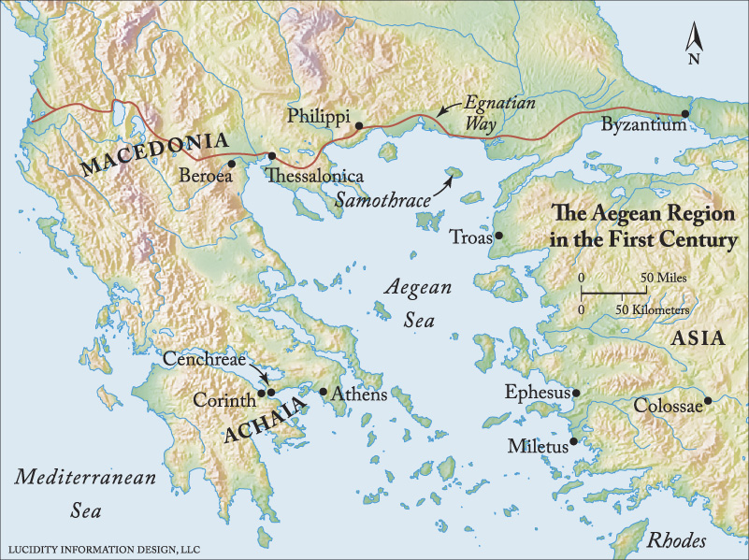
Last week we turned our sanctuary into the Aegean Sea with our east, north and west walls the shores of Turkey, Macedonia and Achaia, or Greece. We perched ourselves on the upper deck of a large cruise ship and watched Paul travel by land from Ephesus north to Troas. He then took a ship from Troas to Philippi, Macedonia and traveled by land through Thessalonica and Berea, then headed south along the west side of the Aegean Sea to Corinth in Achaia. When his plans to head out by ship directly east to Syria and Jerusalem were hindered, he retraced his tracks back to Philippi, across the Aegean by ship to Troas where he had a seven day retreat, if you would, with the seven representative from churches where Paul had worked who were carrying with them a monetary gift to the Jerusalem church.
Izmir
. Assos
Here’s where we pick up the story, in Troas, on Monday morning, after Paul had had no sleep after preaching at least all Sunday evening and until daybreak on Monday. He does something that some of us would consider to be a bit peculiar. He makes arrangements with his team for them to go ahead of him onto the ship from Troas and he would meet them at the next port by walking there.
Now, if the port of Assos is just a brief stop for the ship and not a night’s layover, and if by land it’s at least 15 miles from Troas to Assos, it hardly appears that this would be a leisurely and restful walk for Paul to get to Assos in time to meet up with the ship. So, it seems to beg the question, why did Paul do this? And, since no one apparently knows, this is one opportunity to simply speculate and then move on.
And why Luke even told us adds a bit more to the perplexity. Maybe Luke just wanted to let us know what great physical shape Paul was in that he could pull an all-nighter and still do a 15 mile hike the next morning. It certainly provided him some time to himself, reminding me of how Jesus would intentionally get away from, not only the crowds, but even His own disciples.
We know that Jerusalem was on his mind. We know that he was processing what could be happening to him there with the unrelenting hostilities he faced from resentful Jews who wanted him dead. Which makes me wonder if one of the reasons for him changing his travel plans at Corinth not to travel by ship directly to Jerusalem was maybe that some of these vicious Jews were already on board the ship on which he was scheduled to be a passenger. Maybe not a good idea, he thought.
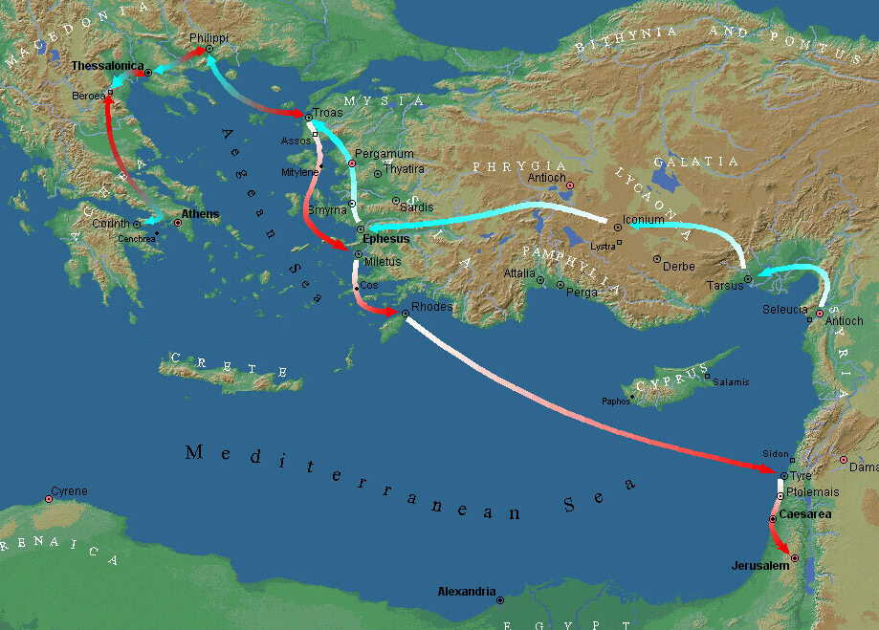
He also had on his mind the church in Ephesus where he had ministered for nearly three years, the longest he had ministered in one place. And, as he was contemplating the thought of never to see his friends from there again, maybe on this morning hike from Troas to Assos he was processing what he could do to have one more visit with the leaders of the church at Ephesus.
By what we will read, Luke seems to suggest that pressure was increasing for Paul to keep moving on to Jerusalem. So, any intentional delay to progress in this regard would need to be considered a high priority. That puts his seven days in Troas as quite an important event. As well, for him to make a multiple-day stop in Miletus to meet with the elders from Ephesus, also suggests this was of uppermost importance given the urgency with which Paul seems to have to get to Jerusalem by Pentecost. Yet, Paul appears to maintain a calm and deliberate demeanor as he orchestrates his travels.
Here’s how our text reads: Acts 20:13-16 (NIV84) ¹³ We went on ahead to the ship and sailed for Assos, where we were going to take Paul aboard. He had made this arrangement because he was going there on foot. ¹⁴ When he met us at Assos, we took him aboard and went on to Mitylene. ¹⁵ The next day we set sail from there and arrived off Kios. The day after that we crossed over to Samos, and on the following day arrived at Miletus. ¹⁶ Paul had decided to sail past Ephesus to avoid spending time in the province of Asia, for he was in a hurry to reach Jerusalem, if possible, by the day of Pentecost.
You may recall that before Paul left Ephesus, there was a huge riot in town over the loss of profits for the silversmiths because so many fewer Ephesians were buying their idols of Artemis because they were becoming Christians and turning away from idol worship.
Now, prior to this riot in Ephesus toward the end of Paul’s nearly three year ministry in that city, Paul had determined to return to Jerusalem via stops in Macedonia and Achaia. But, when he was leaving Corinth after a three month ministry there, he encountered resistance from the Jews and quickly changed his plans on how he was going to get back to Jerusalem.
Verse 16 gives us the impression that were Paul to stop in Ephesus it would eat up precious time that Paul didn’t have to spare. But, it’s possible that Paul avoided Ephesus because he knew if he went there he would get engaged with the people and would not be able to pull himself away in a timely and polite manner and still make it to Jerusalem by Pentecost. It’s also possible that he felt his return to the city of Ephesus could stir up a sleeping tiger and become another huge distraction. So, he simply avoided a stop there altogether.
It’s difficult to know what actually transpired between the ship’s departure from Samos and its arrival at Miletus. They were getting pretty close to Ephesus when they left Samos and sailed for Miletus. It sounds like Paul could have requested the ship to stop at Ephesus had he wanted to get off but decided against it in favor of sending for the elders to meet him at the port in Miletus. That’s how I can make sense of the line in verse 16 that says, “Paul had decided to sail past Ephesus.” That makes it sound like the ship was not making a scheduled stop there unless a passenger was requesting it or had purchased a ticket to do so.
Now if nothing else comes from thinking through Paul’s travel log between Troas and Miletus than to see how he works through the tension between good desires, I will think it has been helpful. Paul wanted to get to Jerusalem by Pentecost. But, he also wanted to spend time with the leaders from Ephesus. So I think what we observe here is a creative solution that achieves both desires though the time margins likely were getting pretty tight. There’s little margin for error or delay.
We all live with similar tensions – good desires pulling at us, and often they’re pressing us to make a choice. Paul knew what his priorities were. They were like pillars on which he structured his life. Meeting with the leaders from Ephesus was too important to pass up.
So, here’s a take away for us from our text so far. God’s word gives us firm ground on which to stand. Let God, through His word, set our priorities and give us the strength to live by them.
¹⁷ From Miletus, Paul sent to Ephesus for the elders of the church.
The implementation of Paul’s decision to send for the elders in Ephesus to come to Miletus to meet with Paul had to have delayed Paul’s travels by multiple days. Some suggest that it would have taken two days for a messenger to get to Ephesus from Miletus and another two days for the elders to make the trek down to Miletus to meet with Paul. We presume that they spent at least a day together. These were the spiritual leaders who were carrying on the ministry that Paul started in Ephesus. The message Paul had for these leaders was of utmost importance to Paul. So, as we read what surely is a summary of his farewell message, let’s consider what Paul deems to be important matters.
My theory is that if it’s important to Paul, it likely should be important for us.
By the way, I think it’s helpful to ask those who have given a farewell address in their past what they considered to be vitally important ingredients to include in their farewell comments. Here’s Paul’s farewell address to the Ephesian elders.
¹⁸ When they (the elders) arrived, he said to them: “You know how I lived the whole time I was with you, from the first day I came into the province of Asia. ¹⁹ I served the Lord with great humility and with tears, although I was severely tested by the plots of the Jews. ²⁰ You know that I have not hesitated to preach anything that would be helpful to you but have taught you publicly and from house to house. ²¹ I have declared to both Jews and Greeks that they must turn to God in repentance and have faith in our Lord Jesus.
Paul gives us here an overview statement of his ministry of teaching in Ephesus. First, it starts with the teacher setting an example by how he lives his life. Paul lived his life to serve the Lord and did it with great humility and with tears in spite of severe testings. In this we see Paul’s character and his genuine concern for the welfare of these disciples. In essence, Paul says, “My teaching is my life.” And, “My life illustrates my message.” That’s called integrity. It’s the union of a person’s life with his message.
Second, he clearly states that Bible teaching needs to be helpful and should be taught publicly and from house to house. One could construe from this the rhythm of gathering as an entire congregation for worship and teaching on Sundays and then meeting in smaller groups in homes throughout the week. And both modes of teaching are to be measured by their helpfulness to the disciples.
Third, by Paul’s standard, all students must be urged to turn to God in repentance and have faith in Jesus Christ. This is the bottom line of Paul’s teaching; repent and believe.
Paul was an open book to his disciples. He was most powerfully a silent teacher by letting his life, his example, illustrate his teachings. But, without question, he was a vocal teacher as he preached what was helpful publicly and from house to house. And, thirdly, he was an open arms teacher as he pled with all people, Jews and Greeks, to repent and believe.
So, what made Paul tick? What stirred his heart? And, what was his passion? He tells us.
²² “And now, compelled by the Spirit, I am going to Jerusalem, not knowing what will happen to me there. ²³ I only know that in every city the Holy Spirit warns me that prison and hardships are facing me. ²⁴ However, I consider my life worth nothing to me, if only I may finish the race and complete the task the Lord Jesus has given me—the task of testifying to the gospel of God’s grace.
Paul was driven by his mission. It was a God-given mission and thus a God-given passion to complete the mission. He even attributes to God the Holy Spirit his passion to get to Jerusalem. Further, he believes that the Holy Spirit has forewarned him about where he would spend a considerable amount of time in the future, as in, prison.
But, even this certain anticipation of imprisonment and hardship did not move him off course in his life’s mission. His objective was to finish his God-given task. We’ve seen this with Paul again and again. He simply refuses to get sidetracked from his life’s assignment.
He stays focused on his mission. Circumstances may change his physical location, but as long as he has breath, he keeps pursuing his mission. His mission gave him purpose in life, to the point of believing that his life meant nothing to him apart from his mission. Paul lived to testify to the gospel of God’s grace.
Later, Paul will write to the church in Philippi, where he had just visited, leaving from there by ship to go to Troas. In his letter to the Philippians, we hear a similar theme. Here Paul tells us what fuels his passion for ministry. It is his bonded relationship with Jesus Christ. Listen to him speak.
Philippians 3:7-4:1 (NIV84) ⁷ But whatever was to my profit I now consider loss for the sake of Christ. ⁸ What is more, I consider everything a loss compared to the surpassing greatness of knowing Christ Jesus my Lord, for whose sake I have lost all things. I consider them rubbish, that I may gain Christ ⁹ and be found in Him, not having a righteousness of my own that comes from the law, but that which is through faith in Christ—the righteousness that comes from God and is by faith. ¹⁰ I want to know Christ and the power of His resurrection and the fellowship of sharing in His sufferings, becoming like Him in His death, ¹¹ and so, somehow, to attain to the resurrection from the dead.
. . . , ¹⁴ I press on toward the goal to win the prize for which God has called me heavenward in Christ Jesus.
The heart of his passion for mission was his union with Christ. His relationship with Christ fueled his passion to fulfill his God-given mission. That’s why he was compelled to finish the race and complete the task Jesus Christ had given him.
How compelling is your mission? Do you know what it is? Do you have a mission statement? Is it rooted in God’s word and in your relationship with Jesus Christ? Is it a God-given mission?
This is important, folks. We all need a mission that rises to the level of ultimate purpose. It will be a mission that is grounded in your relationship with Christ. We will not have a compelling burden to win the lost apart from a dominant relationship with Christ. And friends, we’re talking about a life and death matter when it comes to Christ. Everyone’s eternal destiny rides on their response to Jesus Christ.
Paul tells us that it’s possible to fulfill our obligation in making the gospel of Jesus Christ known to those who have been assigned to us. That’s my take on what Paul tells the Ephesian elders.
²⁵ “Now I know that none of you among whom I have gone about preaching the kingdom will ever see me again. ²⁶ Therefore, I declare to you today that I am innocent of the blood of all men.
What makes Paul innocent of the blood of all men? That there is no one for whom he was responsible who can point a finger at him and say, “Paul, you never told me how I could have a saving relationship with Jesus Christ.” Paul had fulfilled his calling, his mission, because he had proclaimed without hesitancy the whole counsel of God. He had preached the kingdom of God to the extent of his ability.
²⁷ For I have not hesitated to proclaim to you the whole will of God.
Paul did not simply focus on a few pet themes from the Scriptures. He presented the whole purpose of God through his teaching ministry. That could mean that he taught from Genesis to Pentecost. It could mean he taught systematically all the major themes of the Scriptures. It most certainly meant that he was thorough in his teaching and covered a wide spectrum of God’s purposes for reaching out to His creation.
And Paul’s complete teaching included instructions to the leaders of the church. ²⁸ Keep watch over yourselves and all the flock of which the Holy Spirit has made you overseers. Be shepherds of the church of God, which He bought with His own blood.
He tells them to first do regular self examinations. Keep watch over themselves. Pay attention. Don’t get slothful. Don’t drop your guard. Just because you’re a leader doesn’t make you any less vulnerable to sin. Church leaders, keep watch over yourselves.
Secondly, these leaders are to keep watch over those under their care. Now, let me ask you, who gave this assignment? The text says that the Holy Spirit has placed overseers within the church. And, their responsibility is to watch over the members of the church like a shepherd watches over his sheep.
Now, when I combine Paul’s example of giving those under his care the whole purpose or counsel of God with his exhortation to keep watch over the congregation, I believe that Scripture is teaching us that part of the task of the elders of a church is to see to it that the members are getting the breadth of Biblical teaching.
It seems to me, therefore, that it is quite appropriate that church elders inquire of the congregation to assess the extent to which they are getting the whole counsel of God’s word. No church member should be surprised if and when an elder comes along side of him or her and asks, “How are you doing in the study of God’s word? What Bible teachers are you sitting under and what is God teaching you these days?” Those are very appropriate questions that need to be asked if they are to be obedient to their calling.
The reason for this inquiry is out of concern for your welfare. Danger lurks around the corner for all of us and we must know how to discern it and protect ourselves from it. Paul warns these elders of these dangers.
²⁹ I know that after I leave, savage wolves will come in among you and will not spare the flock. ³⁰ Even from your own number men will arise and distort the truth in order to draw away disciples after them. ³¹ So be on your guard! Remember that for three years I never stopped warning each of you night and day with tears.
Just like a parent desiring to see his or her child grow up strong and wise also has to do his share of giving warnings and alerting his child to dangers ahead, so spiritual leaders are to do the same thing. The simple presence of a parent keeps his child in check from wandering off. Thus, Paul’s warnings were not always verbal. Sometimes it came through eye contact. Sometimes by simply being present. He was vigilant in his oversight of his people.
In case you hadn’t caught the importance of God’s word in your spiritual development, Paul reminds us in his closing words.
³² “Now I commit you to God and to the word of His grace, which can build you up and give you an inheritance among all those who are sanctified. ³³ I have not coveted anyone’s silver or gold or clothing. ³⁴ You yourselves know that these hands of mine have supplied my own needs and the needs of my companions. ³⁵ In everything I did, I showed you that by this kind of hard work we must help the weak, remembering the words the Lord Jesus Himself said: ‘It is more blessed to give than to receive.’”
Teachers of God’s word must first be an example, a model, of the truth of Scripture. Secondly, the teaching from Bible teachers must be helpful to the students by building them up into a vital godliness.
³⁶ When he had said this, he knelt down with all of them and prayed. ³⁷ They all wept as they embraced him and kissed him. ³⁸ What grieved them most was his statement that they would never see his face again. Then they accompanied him to the ship.
Again, we simply can’t miss the compassion that Paul had for people. He cared deeply and these men knew it. Paul had made it a priority in his life to build relationships with people as he communicated with them the whole counsel of God.
The other thing that we must not miss here is the cooperation of these church leaders in helping Paul fulfill his mission from God. Paul had called for them to meet him, quite likely on the spur of the moment. They apparently dropped what they were doing and came. They welcomed his encouragements and exhortations.
There were a few times in our parenting that we had to remind our kids that God had given us an assignment to bring them up in the teachings of Scripture and to help them learn obedience. You see, it’s so easy to let life get horizontal. Like it’s all about you and me or parent and child or husband and wife. But, for Christians, life is never just horizontal. There is always the vertical dimension in all of our relationships and activities. We are first of all servants of Christ. We are under His authority if we belong to the kingdom of God. And sometimes our kids need to understand that as parents, we, too, have to give an account for our actions, attitudes and thoughts.
My prayer is that our relationships within this church fellowship will always have the vertical relationship with Christ as the most vital component. It is Christ who joins us together in a common mission to make the gospel known to this community and to places all around the world. I can easily imagine that the elders from Ephesus had a surprisingly delightful experience in Miletus with Paul. I believe they were marked by the occasion and had hopes it would happen again in the future. Just as God joined these believers together in a common relationship and a common mission, it is my prayer that the same is true for us. Let’s do our God-given mission together.

