Sunday, December 13, 2015 – New Heights Christian Church, Kent, WA – Pastor Micah Adamson
Title: Jesus’ Miraculous Conception: God’s chosen sign of His ability to save
Text: Isaiah 7:1-17 & Matthew 1:18-25
Isaiah 7:14 (NIV84) Therefore the Lord himself will give you a sign: The virgin will be with child and will give birth to a son, and will call him Immanuel.
Introduction: Why do Christmas songs refer so often to the Exile?
O come, O come, Emmanuel
O come, O come, Emmanuel,
And ransom captive Israel,
That mourns in lonely exile here
Until the Son of God appear.
Rejoice! Rejoice!
Emmanuel shall come to thee, O Israel.

Matthew’s genealogy of Jesus summarizes Israel’s history like this:
Matthew 1:17 (NIV84)
¹⁷ Thus there were fourteen generations in all from Abraham to David, fourteen from David to the exile to Babylon, and fourteen from the exile to the Christ.
Matthew | Bible | Summary | People
[…] | Genesis 1-11 | Paradise Lost -  People Chosen | Adam - Abraham
Matthew 1:2-6 | Genesis 12 -  Ruth | Kingdom Promised -  Kingdom Come | Abraham - David
Matthew 1:7-11 | 1 Samuel -  2 Chronicles | Kingdom Decline -  Kingdom Lost | David - Jehoiachin/Jeconiah (Exile)
Matthew 1:12-16 | Ezra-Malachi -  Matthew-John | Return from Exile -  Return of the King | Jehoiachin/Jeconiah (Exile) - Jesus (Christ)

3 Reasons the Exile figures so prominently in the Christmas story:
- At Christmas, Israel was still in the 14 generation block of time characterized by the Exile that would only end with the Messiah.
- All of the major and minor prophets that talk about the coming of the Messiah belong either to the 14 generation block leading up to the Exile or the 14 generation block after the Exile.
- The whole story from Genesis-Malachi is characterized by the Exile from Eden that would only end with the coming of the Messiah.

Matthew 1 quotes from Isaiah 7 linking Jesus’ birth back to the time of the Exile:
Matthew 1:23 (NIV84)
²³ “The virgin will be with child and will give birth to a son, and they will call him Immanuel”—which means, “God with us.”
- Ahaz = the king Isaiah spoke to, Jeconiah/Jehoiachin = the last king of Judah, Zerubbabel = the rightful heir who returned from Exile but wasn’t king (Ezra/Nehemiah/Haggai/Zechariah)
- Joseph = the rightful heir in the kingly line of David in his day who also wasn’t king.
- Herod’s response in Matthew 2 to the wise men asking where the Messiah was shows how Joseph likely would have been treated if it was widely remembered that Joseph was the heir.
How does Isaiah 7 tell us about Jesus?
Problem/Solution of Isaiah:
- Problem of Isaiah: Israel and Judah have rejected God and are going to be sent into Exile just like the law said would happen (Leviticus 18:28, 20:22, Deuteronomy 28:63-64).
- Solution of Isaiah: God graciously still plans to preserve the kingly line of David and save His people and the world through the Messiah after the Exile, although they don’t deserve it.

Outline of Isaiah:
- Isaiah 1-35 – Bad news: Israel and Judah are going into Exile for their sin
(Ahaz is threatened by Israel/Aram, then Assyria)
- Isaiah 36-39 – Turning Point: Israel is taken into Exile by Assyria, but Judah gets a stay of execution to wait for Babylon (Hezekiah is threatened by Assyria, then Babylon)
- 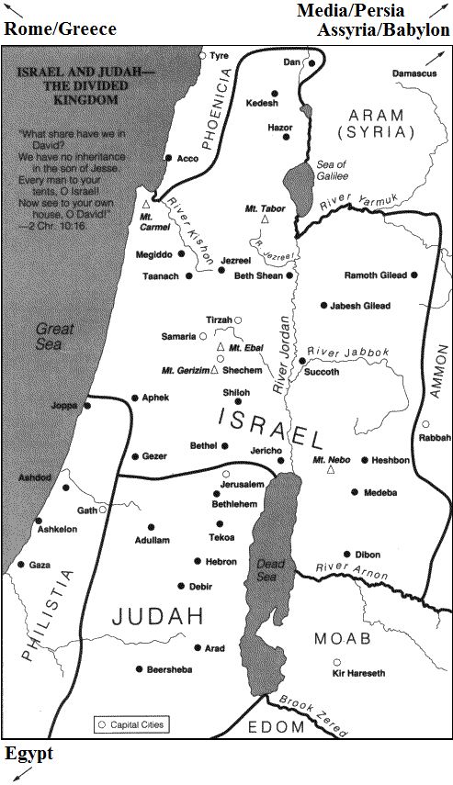Isaiah 40-66 – Good News: God will save David’s line, Israel and Judah, and the world through the Messiah (God will send the Christ/Messiah/Anointed One/Coming King to minister by His Spirit after the Exile)

Geography of Isaiah:
- Rome (in Italy)
- Greece
- Media/Persia (in Iran)
- Assyria – Capital: Nineveh (in Iraq)
- Babylon (in Iraq)
- Aram – Capital: Damascus (in Syria)
- Israel – Capital: Samaria
(“Israel” is also called “Ephraim” or
“Joseph” after the largest tribe in Israel)
- Judah – Capital: Jerusalem
- Egypt

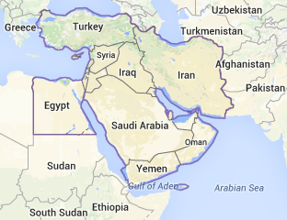
Isaiah 7:1-6 (NIV84)
7 When Ahaz son of Jotham, the son of Uzziah, was king of Judah, King Rezin of Aram [Syria] and Pekah son of Remaliah king of Israel marched up to fight against Jerusalem [the capital of Judah], but they could not overpower it.
² Now the house of David [Judah] was told, “Aram [Syria] has allied itself with Ephraim [Israel]”; so the hearts of Ahaz and his people [Judah] were shaken, as the trees of the forest are shaken by the wind.
³ Then the Lord said to Isaiah, “Go out, you and your son Shear-Jashub [a remnant will return], to meet Ahaz [king of Judah] at the end of the aqueduct of the Upper Pool, on the road to the Washerman’s Field. ⁴ Say to him, ‘Be careful, keep calm and don’t be afraid. Do not lose heart because of these two smoldering stubs of firewood—because of the fierce anger of Rezin and Aram [Syria] and of the son of Remaliah [king of Israel]. ⁵ Aram [Syria], Ephraim [Israel] and Remaliah’s son [king of Israel] have plotted your ruin, saying, ⁶ “Let us invade Judah; let us tear it apart and divide it among ourselves, and make the son of Tabeel [a Syrian name] king over it.”
- The plot that Ahaz is facing is that Israel and Aram/Syria plan to take over Judah and give it an Aramean/Syrian king.

Isaiah 7:7-9 (NIV84)
⁷ Yet this is what the Sovereign Lord says:
“ ‘It will not take place,
it will not happen,
⁸ for the head of Aram [Syria] is Damascus [the capital of Syria],
and the head of Damascus [the capital of Syria] is only Rezin [the king of Syria].
Within sixty-five years
Ephraim [Israel] will be too shattered to be a people.
⁹ The head of Ephraim [Israel] is Samaria [the capital of Israel],
and the head of Samaria [the capital of Israel] is only Remaliah’s son [the king of Israel].
If you do not stand firm in your faith,
you will not stand at all.’ ”
- God shrinks the country to its capital and the capital to its king to show that the threat is small.
- WWII: The head of Germany is only Berlin, the head of Berlin is only Hitler, who I can take!
- God will deliver Judah from Israel and Aram, but God starts to hint that if Ahaz doesn’t trust God, he will not be delivered from the force that destroys Israel and Aram.

Isaiah 7:10-17 (NIV84)
¹⁰ Again the Lord spoke to Ahaz, ¹¹ “Ask the Lord your God for a sign, whether in the deepest depths or in the highest heights.”
¹² But Ahaz said, “I will not ask; I will not put the Lord to the test.”
¹³ Then Isaiah said, “Hear now, you house of David! Is it not enough to try the patience of men? Will you try the patience of my God also? ¹⁴ Therefore the Lord himself will give you a sign: The virgin will be with child and will give birth to a son, and will call him Immanuel. ¹⁵ He will eat curds and honey when he knows enough to reject the wrong and choose the right. ¹⁶ But before the boy knows enough to reject the wrong and choose the right, the land of the two kings you dread will be laid waste. ¹⁷ The Lord will bring on you and on your people and on the house of your father a time unlike any since Ephraim [Israel] broke away from Judah—he will bring the king of Assyria.”
- God says that He will destroy Aram and Israel by Assyria, but Assyria is the real danger for Judah too. Ahaz and Judah has to trust God to save them or Assyria will destroy them.
- Ahaz sounds very pious in his refusal to ask for a sign, but Isaiah takes it as a lack of faith.
- When the devil tempts you to say that God can't provide for you, you should tell him that it is written: "Do not put the Lord your God to the test" like Jesus did, but when God asks you to pick a sign that he can provide for you, you should pick one! (Matthew 4:7, Deut. 6:16).

How does Ahaz’s story end?
- Isaiah 7 – Ends with Judah going back into the stone-age. Their vineyard and grain farmers will become nomadic herders/hunter-gathers (as evidenced by the coming son eating curds and honey instead of oatmeal and raisins). But, God will still care for Judah in these tough times.
- Isaiah 8 – Isaiah was engaged to be married to a virgin when Isaiah 7 was written. He got married and had another son named Maher-Shalal-Hash-Baz (quick to the plunder, swift to the spoil). In the time it took Isaiah and his new wife to get married, conceive, give birth, and ween their son, Israel and Aram were conquered by Assyria.
- If Isaiah 7-8 were all we had, we would probably conclude that the prophecy of a baby born of a virgin was just an odd way of describing Isaiah’s son to be born to his future wife who was a virgin at the time of the prophecy.
- Isaiah 9 – But, Isaiah keeps talking about the baby who was to come after his son is born. It’s clear that the promised baby will be in the kingly line of David rather than in Isaiah’s family. This baby is also described in terms that can only be describing God incarnate. These verses right in the context of Isaiah lead us to expect that a virgin may be with child in a more miraculous sense in the future.

Isaiah 9:6-7 (NIV84)
For to us a child is born,
to us a son is given,
and the government will be on his shoulders.
And he will be called
Wonderful Counselor, Mighty God,
Everlasting Father, Prince of Peace.
⁷ Of the increase of his government and peace
there will be no end.
He will reign on David’s throne
and over his kingdom,
establishing and upholding it
with justice and righteousness
from that time on and forever.
The zeal of the Lord Almighty
will accomplish this.

- Isaiah 7-9 – Ahaz rejected God’s chosen sign of salvation through his son. Ahaz didn’t trust God to preserve his line or his kingdom. He took matters into his own hands instead.
- 2 Kings 16 – Ahaz bribed Assyria to come attack Israel and Aram. He thought of his salvation as being his own doing. Ahaz modified the temple of God to incorporate Assyrian worship right into the temple. Ahaz even sacrificed his own son to a false god. Child sacrifice is always horrible, but this is doubly bad since Ahaz was attacking the messiah’s line with his own hand. Ahaz was aggressively not trusting God.
- 2 Kings 18-20 & Isaiah 37-39 – Assyria also thought of their conquest of Israel as the result of trusting in their false gods. Hezekiah rejected his father Ahaz’s ways. When Assyria came to attack Judah, it was only by trusting God that Judah was saved from going into Exile too.
- Isaiah 7 – Since Ahaz wouldn’t choose a sign to show that God would save him (like his son Hezekiah did when he was sick in Isaiah 38), God chose the sign for the line of David to prove that He could save David’s line and all Israel through the coming Messiah.
- Isaiah 8 – God gave a preview of His ability to save in that Israel and Aram were destroyed by the time Isaiah’s future wife had time to get married, conceive, have a son, and ween him.
- Isaiah 9 – But just as the sun moving backward on the steps for Hezekiah was a sign that Hezekiah would be healed in the future, so God saving Ahaz from Israel and Aram was only a sign pointing forward to how he would save Israel in the future through Jesus.

How does Matthew 1:18-25 use Isaiah 7?
Matthew 1:18-25 (NIV84)
¹⁸ This is how the birth of Jesus Christ came about: His mother Mary was pledged to be married to Joseph, but before they came together, she was found to be with child through the Holy Spirit. ¹⁹ Because Joseph her husband was a righteous man and did not want to expose her to public disgrace, he had in mind to divorce her quietly.
²⁰ But after he had considered this, an angel of the Lord appeared to him in a dream and said, “Joseph son of David, do not be afraid to take Mary home as your wife, because what is conceived in her is from the Holy Spirit. ²¹ She will give birth to a son, and you are to give him the name Jesus, because he will save his people from their sins.”
²² All this took place to fulfill what the Lord had said through the prophet: ²³ “The virgin will be with child and will give birth to a son, and they will call him Immanuel”—which means, “God with us.”
²⁴ When Joseph woke up, he did what the angel of the Lord had commanded him and took Mary home as his wife. ²⁵ But he had no union with her until she gave birth to a son. And he gave him the name Jesus.
- While I don’t think Joseph could have explained all of what Isaiah teaches about the Messiah at the time, in order to marry Mary, Joseph had to stand in Ahaz’s place as the rightful heir to the throne of Israel and believe the promise of Isaiah 7.
  - Jesus was miraculously conceived of a virgin by the Holy Spirit without a human father.
  - As such Jesus was the coming king (Christ) in the line of David who would rule forever.
  - As such Jesus was also the God/Man of Isaiah 9.
  - As such Jesus was also God’s true servant from Isaiah 52.
  - As such Jesus would also be God’s provision for sin described in Isaiah 53.
  - All in all, God would save His people and the world through saving the line of David.
- Joseph demonstrated that he believed the promise of Isaiah 7 by marrying Mary and accepting Jesus as his son.
Conclusion: God chose Jesus’ miraculous birth as the sign that God is with us to save!
- The moral of the story is to be like Joseph instead of like Ahaz.
- We are being asked to believe the same things as Joseph.
- We aren’t exactly like Joseph since we don’t get to be the king in the line of David; that’s Jesus’ job now and forever! But, we do get to be saved and ruled by Jesus if we trust Him.
- Don’t trust your riches to save you like Ahaz did by trying to pay off one of his enemies to save him from the other. We have much subtler ways of trusting our money instead of God.
- Don’t try to worship both the true God and other gods like Ahaz did.
- Don’t return to the god of your ancestors, if your ancestors didn’t worship the true God like Ahaz did. The historical idolatry of our family or our nation is no better than modern idolatry. Return to the true God of the Bible who has revealed himself in Jesus!
- Don’t trust in your own religiousness to save you like Ahaz did by trying to cover all his bases. If someone tells you that you can and must work hard enough to make God happy with you, or that there are just a few more rituals you need to add before Jesus’ work is enough to save you, be careful! That sounds like they’re talking about a different god than the God who has revealed himself in Jesus as the final sacrifice for our sins.
- However, obedient faith like Joseph’s is the appropriate response to God’s salvation given to us in Jesus. But, notice that Joseph’s obedience was first and foremost an act of faith which trusted in God to save through Christ. By marrying Mary, Joseph was accepting Jesus as the Messiah and savior for all of who He is in Isaiah (which we’ll examine more next week).

Benediction:
Matthew 1:23/Isaiah 7:14 (NIV84)
“The virgin will be with child and will give birth to a son, and they will call him Immanuel”—which means, “God with us.”

Isaiah 9:6 (NIV84)
For to us a child is born,
to us a son is given,
and the government will be on his shoulders.
And he will be called
Wonderful Counselor, Mighty God,
Everlasting Father, Prince of Peace.

Isaiah 7:9b (NIV84)
If you do not stand firm in your faith,
you will not stand at all.’ ”

Amen.

